 | 
COUNCIL ASSESSMENT REPORT
HUNTER AND CENTRAL COAST REGIONAL PLANNING PANEL

PANEL REFERENCE & DA NUMBER | PPSHCC-337 – DA/60944/2021
PROPOSAL | Coastal Protection Works
ADDRESS | Lot 3 DP 12022, Lot 2 DP 12022, Lot 1 DP 12022  85, 87, 89 Ocean View Drive Wamberal
APPLICANT | N G Karam - c/o Slater Architects
OWNER | Wamberal Investment Co Pty Ltd – 85 Ocean View Drive  Ms D J Elkorr – 87 Ocean View Drive  E Karam and N G Karam – 89 Ocean View Drive
DA LODGEMENT DATE | 12 May 2021
APPLICATION TYPE | Development Application
REGIONALLY SIGNIFICANT CRITERIA | Section 2.19(1) and Clause 8A of Schedule 6 of State Environmental Planning Policy (Planning Systems) 2021 declares the proposal regionally significant development as:  8A Certain coastal protection works  - The following development on land within the coastal zone that is directly adjacent to, or is under the waters of, the open ocean, the entrance to an estuary or the entrance to a coastal lake that is open to the ocean—  - development for the purpose of coastal protection works carried out by a person other than a public authority, other than coastal protection works identified in the relevant certified coastal management program,
COST OF DEVELOPMENT | $855,516 (excluding GST)
CLAUSE 4.6 REQUESTS | Not Applicable
LIST OF ALL RELEVANT PLANNING CONTROLS (S4.15(1)(A) OF EP&A ACT) | - Coastal Management Act 2016  - Environmental Planning and Assessment Act 1979  - State Environmental Planning Policy (Planning Systems) 2021  - State Environmental Planning Policy (Building Sustainability Index: BASIX) 2004  - State Environmental Planning Policy (Resilience and Hazards) 2021  - Central Coast Local Environmental Plan 2022  - Central Coast Development Control Plan 2022  - Gosford Local Environmental Plan 2014  - Gosford Development Control Plan 2013
TOTAL & UNIQUE SUBMISSIONS | 48 submissions across 2 notification periods
KEY ISSUES | - Inconsistent with R2 Low Density zone objectives  - Coastal Protection Works - Potential for increased coastal hazards and impact on the coastal foreshore and adjacent properties.  - Compliance with Chapter 2 Coastal Management of State Environmental Planning Policy (Resilience and Hazards) 2021  - Visual amenity and scenic qualities of the coast  - Level of Compliance with Gosford Development Control Plan 2013  - Chapter 2.1 Character  - Chapter 6.2 Coastal Frontage  - Sediment and Erosion Control  - Maintenance Management  - Insufficient Information
DOCUMENTS SUBMITTED FOR CONSIDERATION | - Coastal Engineering Report and Statement of Environmental Effects for Coastal Protection Works, at 85-89 Ocean View Drive Wamberal, Horton Coastal Engineering dated 7 May 2021.  - Coastal Engineering Response to Council Request for Information on DA 60944/2021 for Coastal Protection Works at 85-89 Ocean View Drive Wamberal, Horton Coastal Engineering 2023 dated 31 August 2021.  - Coastal Engineering Response to Council Requests for Information on DA60944/2021 for Coastal Protection Works at 85-89 Ocean View Drive Wamberal, DA60465/2020 for Construction of a New Dwelling House and Swimming Pool at 85-87 Ocean View Drive Wamberal, and DA63277/2021 for a Swimming Pool and Associated Works at 89 Ocean View Drive Wamberal, Horton Coastal Engineering dated 1 March 2023.  - Structural Engineering Plans, prepared by Northrop, Ref: NL201558, dated 22 January 2021.  - Structural Engineering Advice, prepared by Northrop, Ref: NL201558, dated 25 February 2021.  - Structural Engineering Advice and Plans, prepared by Northrop, Ref: NL201558, dated 31 August 2021.  - Geotechnical Assessment, prepared by JK Geotechnics, Ref: 32215Rrpt, dated 22 January 2021.  - Survey Plan & Letter, Intrax, dated 10 March 2021  - Statement of Environmental Effects, Doug Sneddon Planning Pty Ltd, dated September 2021  - Landscape Plan, Terras Landscape Architects, Job No.13581.5 dated 19 March 2021  - Architectural Plans, Slater Architects, Project No. 14517, Rev 3 dated 19 March 2021
SPECIAL INFRASTRUCTURE CONTRIBUTIONS (S7.24) | Nil
RECOMMENDATION | Refusal
DRAFT CONDITIONS TO APPLICANT | Not Applicable
PLAN VERSION | Architectural Plans, Slater Architects, Project No. 14517, Rev 7 dated 19 May 2023
SCHEDULED MEETING DATE | 20 August 2025
PREPARED BY | Karen Hanratty – Principal Development Planner
DATE OF REPORT | 11 August 2025

EXECUTIVE SUMMARY

The development application (DA/60944/2021) seeks consent for coastal protection works across three properties identified as 85-87-89 Ocean View Drive Wamberal. DA/60944/2021 also includes an inground swimming pool on 85-87 Ocean View Drive. A dwelling house has been constructed on 89 Ocean View Drive. A dwelling house has been approved on 85-87 Ocean View Drive under DA/60465/2020 however has not yet been constructed.

The site is located on the eastern side of Ocean View Drive opposite the corner of Bundara Avenue. It adjoins the beach to the east and Ocean View Drive to the west. The site has a combined area of 2219.4 sqm and a beach frontage of 55.545m.

The site and properties along the beachfront are located in a low density residential area. The site is zoned R2 Low Density Residential under Gosford Local Environmental Plan 2014. Coastal protection works are not a permissible use in the R2 zone. The development is permissible under section 2.16 of State Environmental Planning Policy (Resilience and Hazards) 2022. The proposal is inconsistent with various provisions of the planning controls for development with a sensitive coastal zone under the SEPP and is likely to increase the risk of coastal hazard on adjoining development and the beachfront.

There were no concurrence requirements from agencies for the proposal and the application is not integrated development pursuant to Section 4.46 of the Environmental Planning and Assessment Act 1979 (‘EP&A Act’).

The application was placed on public exhibition from 21 May 2021 to 11 June 2021, with five (5) submissions being received by way of objection. The revised proposal (removal of swimming pools) was notified 5 October 2021 to 26 October 2021. A total of 46 submissions were received by way of objection and 2 submissions in support stating the proposal is an excellent initiative to protect property.

These submissions which raised a number of matters although the predominant concern being the detrimental impact on the coastal foreshore and adjacent properties and are considered further in this report.

The application is referred to the Hunter and Central Coast Planning Panel (‘the Panel’) as the development is ‘regionally significant development’, pursuant to Section 2.19(1) and subject to clause 8A of Schedule 6 of State Environmental Planning Policy (Planning Systems) 2021.

The development application was lodged when the Gosford Beaches Coastal Zone Management Plan (Plan) was a “certified coastal management program” (as defined in the former SEPP (Coastal Management) 2018). However, that Plan ceased to exist/was repealed in 2023.

Clause 8A of Schedule 6 of the SEPP (Planning Systems) 2021 commenced before the repeal of the Plan. As soon as the Plan ceased operation, there was no coastal protection works identified in the relevant certified coastal management program, that existed. Clause 8A of SEPP (Planning Systems) 2021 is also a transferred provision, so “the transfer does not affect the operation (if any) or meaning of the provision, and accordingly the provision is to be construed as if it had not been so transferred” (s 30A(2) Interpretation Act 1987).

A briefing was held with the Panel on 12 May 2025 where key issues were discussed, including zoning and permissibility of the proposed development.

The key issues associated with the proposal included:

- Inconsistent with R2 Low Density zone objectives
- Coastal Protection Works - Potential for increased coastal hazards and impact on the coastal foreshore and adjacent properties.
- Compliance with Chapter 2 Coastal Management of State Environmental Planning Policy (Resilience and Hazards) 2021
- Visual amenity and scenic qualities of the coast
- Level of Compliance with Gosford Development Control Plan 2013
  - Chapter 2.1 Character
  - Chapter 6.2 Coastal Frontage
- Sediment and Erosion Control
- Maintenance Management
- Insufficient Information

Following consideration of the matters for consideration under Section 4.15(1) of the EP&A Act, the provisions of the relevant State environmental planning policies, in particular State Environmental Planning Policy (Resilience and Hazards) 2021, the proposal cannot be supported.

Following a detailed assessment of the proposal, pursuant to Section 4.16(1)(b) of the EP&A Act, DA/60944/2021 is recommended for refusal subject to the reasons contained at Attachment A of this report.

- THE SITE AND LOCALITY

  - The Site

The subject site comprises three trapezoidal lots and legally described as Lot 3 DP 12022, Lot 2 DP 12022, Lot 1 DP 12022, known as 85, 87, 89 Ocean View Drive Wamberal. The site has a frontage to Ocean View Drive and a rear beachfront boundary (Remembrance Drive) as shown in Figure 1.

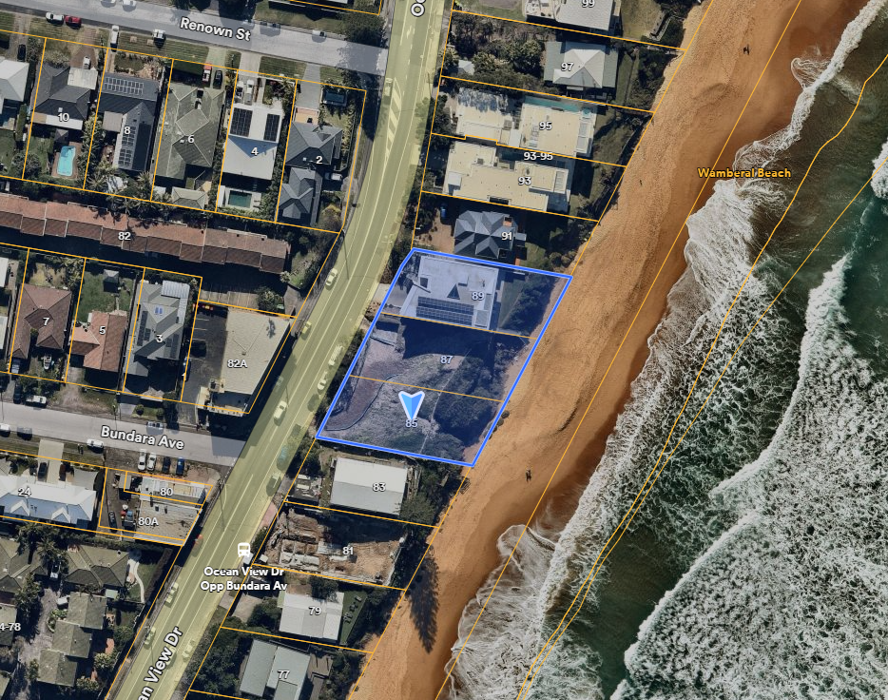
Figure 1 – Site and Locality Plan (Source: nearmap 14/07/2025)

The site is mapped in the Coastal Use Area and the Coastal Environment Area under State Environmental Planning Policy (Resilience and Hazards) 2021 and is therefore located in the coastal zone under Section 5 of the Coastal Management Act 2016.

The site does not contain any significant vegetation and is not identified as bushfire prone land or subject to flood related development controls. The site is mapped as comprising Class 5 Acid Sulfate Soils.

Anecdotal evidence suggests that historic waste material, including asbestos, has been used as fill material in foredunes along Wamberal Beach. Council has collected asbestos fragments and other wastes from the beach following storm events.

Lot 1 DP 12022 – 89 Ocean View Drive Wamberal

The site contains a 3-storey dwelling house. The site rises from about RL 5.5m AHD along the western boundary fronting Ocean View Drive to the top of the coastal dune at approximately RL 10.8m - 11.3m AHD, before falling towards the beach to approximately RL 4.1m along the eastern boundary. Lot 1 has an area of 746.1sqm.

Lots 2 & 3 DP 12022 – 85-87 Ocean View Drive Wamberal

The land is vacant; does not contain any native vegetation or fauna habitat; and is not affected by easements. DA/60465/2020 for new dwelling house was approved on 1 March 2024.

The topography of the site varies from approximately RL10m AHD at the dune escarpment, increasing landward to approximately RL 10.8m AHD, at this point the site slopes down to the site frontage to approximately RL 5.3m AHD. Seaward from the dune escarpment the land slopes to the beach to approximately RL 4.5m AHD. Lots 2 & 3 have a combined area of 1473.3sqm.

The site comprising three properties has a combined area of 2219.4 sqm and a beach frontage of 55.545m.

Figures 2 & 3 show the current state of the site from the beach prior to the Briefing Meeting on 12 May 2025 . Figure 4 shows the street frontage of the site at Ocean View Drive.
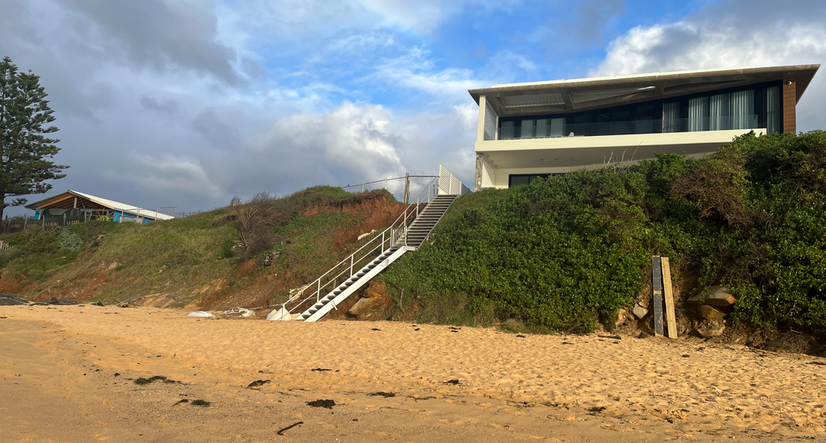
89 Ocean View Drive
85-87 Ocean View Drive

Figure 2 – Subject site beach frontage looking south from 89 Ocean View Drive
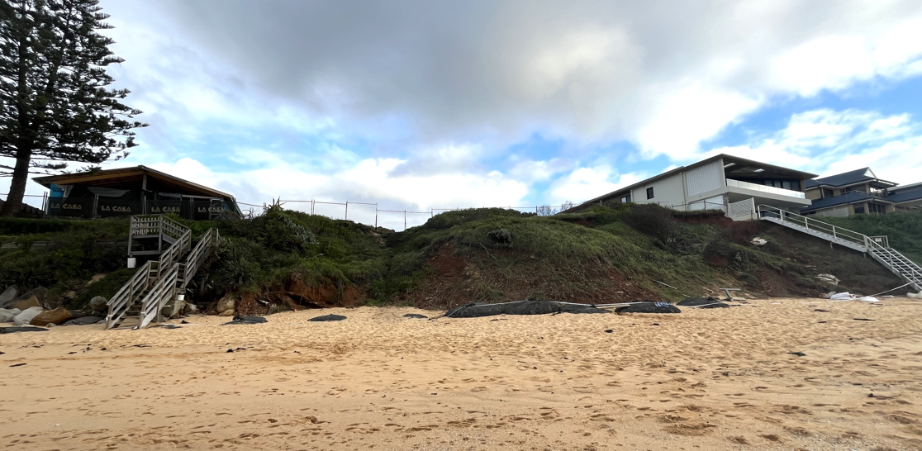
89 Ocean View Drive
85-87 Ocean View Drive

Figure 3 – Subject site beach frontage looking north

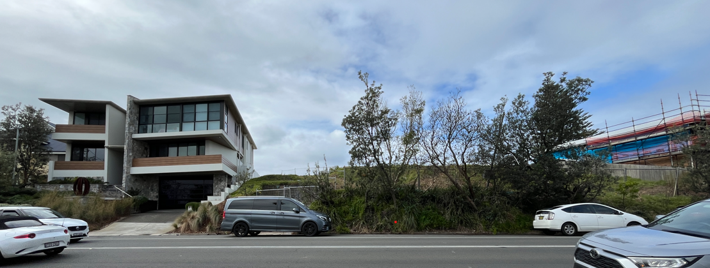
89 Ocean View Drive
85-87 Ocean View Drive

Figure 4 – Subject site street frontage

  - The Locality

The site is located within a low-density residential area with beach front view and access.

Surrounding and nearby land contains detached dwelling houses, with a variety of dwelling types including larger new dwellings and older cottages that are yet to be redeveloped.

The site is located opposite commercial zoned land to the western side of Ocean View Drive containing restaurants and cafes and including a part three storey development to the north-west including ground floor restaurants and accommodation above.

- THE PROPOSAL AND BACKGROUND

  - The Proposal

The proposal seeks consent for the construction of coastal protection works over three land parcels 85-87-89 Ocean View Drive and an inground swimming pool on 85-87 Ocean View Drive as shown in Figure 5 and a Landscape Plan in Figure 6.

Figure 7 provides a perspective of the seawall from the beach.

Figures 8 & 9 provide structural drawings prepared by Northrop dated 22 January 2021.

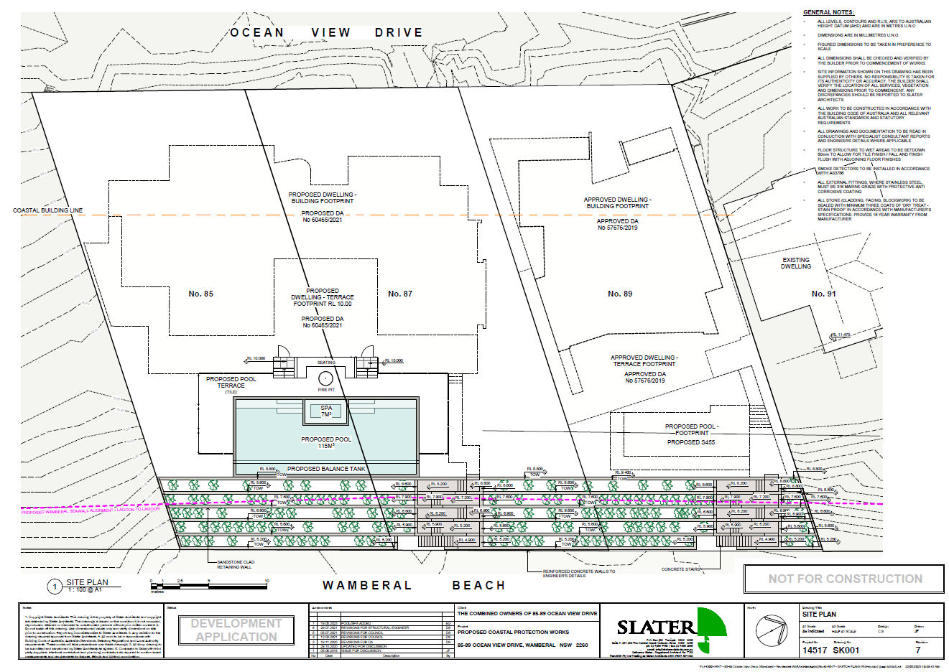
Figure 5 – Site Plan

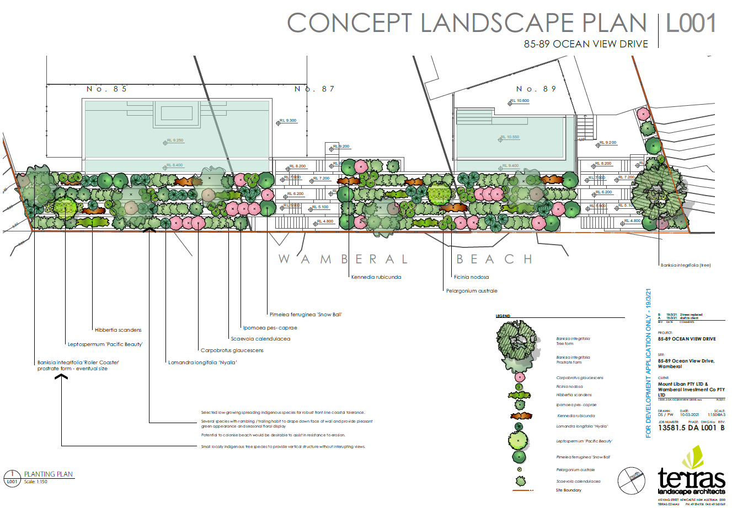
Figure 6 – Landscape Plan

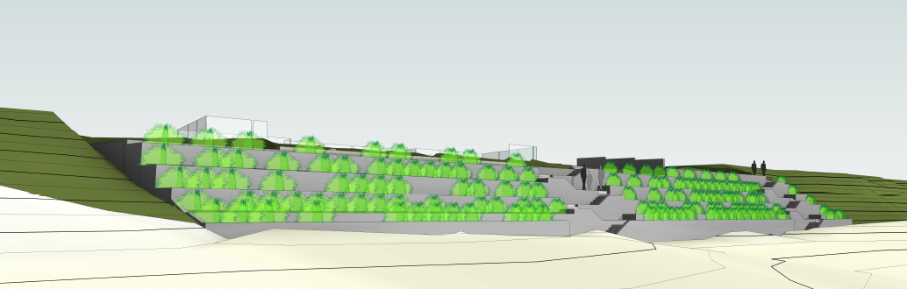
Figure 7 – Perspective

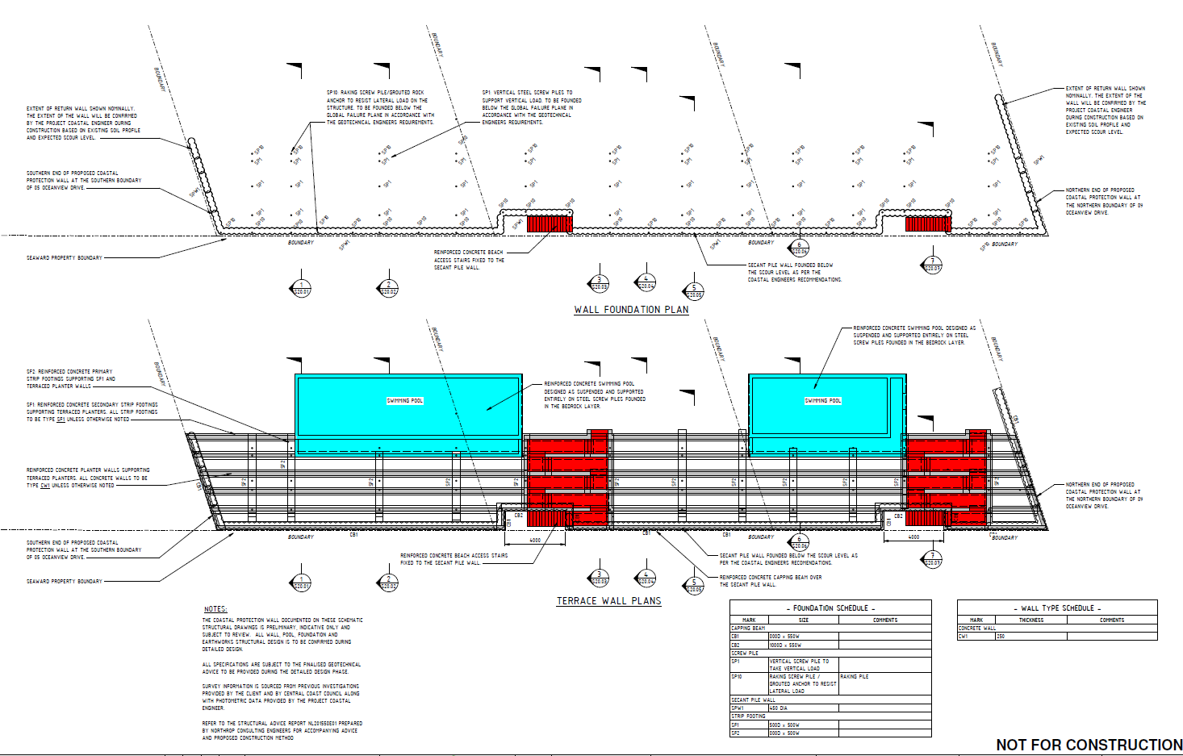
Figure 8 – Structural Drawing Terrace Walls – Plan (Northrop, Job No. NL201558 dated 22/01/2021)

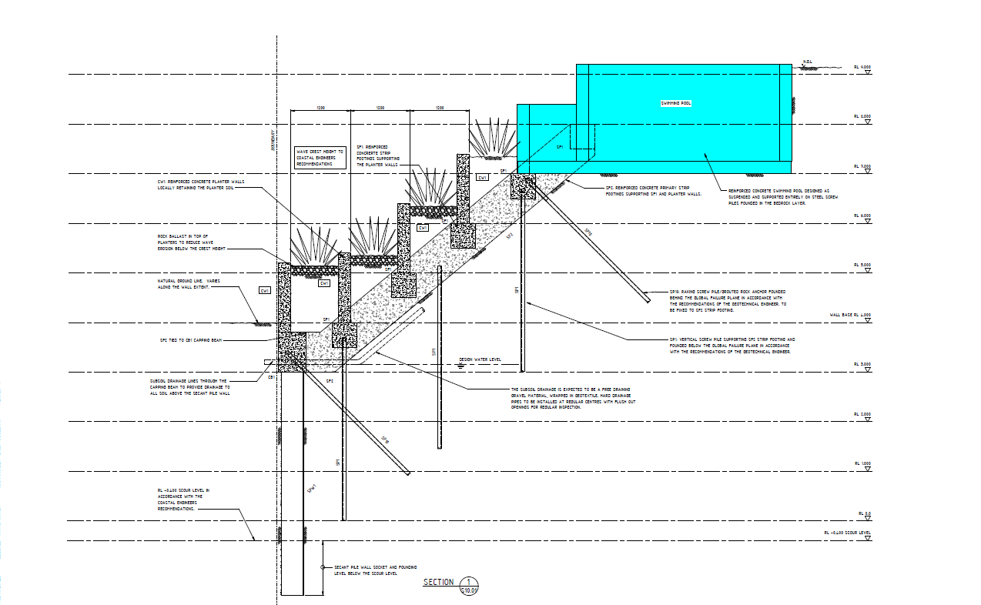
Figure 9 – Structural Drawing Section 2 (Northrop, Job No. NL201558 dated 22/01/2021)

Table 1: Development Data
Control | Proposal
Site area | 2219.4sqm
FSR / GFA | 0.5:1 – there is no GFA applicable for the proposal
Height of Building | 8.5m
Clause 4.6 Request | Not sought
Landscaped area | Landscape plan submitted
Car Parking Spaces | Not applicable to this proposal
Setbacks | Subject to assessment under Chapter 6.2 Coastal Frontage of Gosford Development Control Plan 2013

  - Background

A chronology of the subject development application and other development applications over the three land parcels is outlined in Table 2.

Table 2: Chronology of the DA
Date | Event
12 May 2021 | DA lodged for Coastal Protection Works and two swimming pools over 3 properties on 85-87-89 Ocean View Drive Wamberal comprising an inground swimming pool on 85-87 Ocean View Drive and an inground swimming pool on 89 Ocean View Drive.
21 May 2021 to  11 June 2021 | Exhibition of DA - 5 Submissions received.
21 June 2021 | Request for Information
29 July 2021 | Request for Information
2 September 2021 | Revised plans received removing the swimming pools from the application for coastal protection works.
5 October 2021 to  26 October 2021 | Exhibition of revised application.
20 December 2021 | External Coastal Engineer engaged to provide comment.
21 June 2022 | External Coastal Engineer comments received.
27 July 2022 | External Coastal Engineer comments provided to applicant.
1 March 2023 | Response from Applicants Coastal Engineer (Horton Coastal Engineering) to Council’s RFI dated 27 July 2022.
15 May 2023 | Further request to Council’s External Coastal Engineer to review response from Horton Coastal Engineering (1 March 2023) - Council’s Catchments to Coast team.  Council’s Catchments to Coast team consider the response does not provide the additional information requested.
22 May 2023 | Council advised External Coastal Engineers to hold off on providing further response.
22 May 2023 | Applicant requested DA/60944/2021 amended to include swimming pool on 85-87 Ocean View Drive that was previously removed (Refer Figure 5)
31 December 2023 | The Coastal Zone Management Plan was repealed.
20 March 2024 | Applicant requested DA to be determined in its current form
Oct - Nov 2024 | Council advised DA to be referred to Regional Planning Panel (the Panel)
7 January 2025 | DA/60944/2021 referred to the Panel
10 February 2025 | Panel site inspection
12 May 2025 | Kick-off Panel briefing

  - Site History

Relevant DA history for the site.

- 85 Ocean View Drive Wamberal
- DA/44953/2013 for demolition of existing dwelling and construction of new dwelling, refused on 19 May 2014
- DA/49330/2016 for alteration to existing dwelling and new parking bay, approved on 18 May 2016
- DA/51856/2017 for demolition of a fire damaged dwelling and structures, approved on 12 April 2017
- DA/51692/2017 for new dwelling and detached garage, approved on 30 June 2017. This development has not been constructed.
- DA/60465/2020 for new dwelling lodge 21 December 2020 over 2 lots, 85-87 Ocean View Drive Wamberal, approved on 1 March 2024.

- 87 Ocean View Drive Wamberal
- BA/40232/1986 Alterations to existing dwelling, approved on 4 December 1986
- DA/27512/2005 for demolition of existing dwelling and construction of a new dwelling, approved on 6 October 2005. This development has not been constructed.
- DA/60465/2020 for new dwelling lodge 21 December 2020 over 2 lots, 85-87 Ocean View Drive Wamberal, approved on 1 March 2024.

- 89 Ocean View Drive Wamberal
  - DA/57676/2019 New Dwelling and Associated Works, approved on 28 February 2020.
  - DA/63277/2021 Inground swimming pool, lodged 1 October 2021. Exhibition period - 5 October 2021 to 26 October 2021 – 2 submissions received. DA has not been determined.

- DA/60944/2021 for Coastal Protection Works and two swimming pools was lodged on 12 May 2021 over 3 properties on 85-87-89 Ocean View Drive Wamberal comprising an inground swimming pool on 85-87 Ocean View Drive and an inground swimming pool on 89 Ocean View Drive.
  - This application has been modified as follows:
    - The swimming pools were removed from this application and DA/60465/2020 was amended to include an inground swimming pool
    - DA/63277/2021 was lodged for an inground swimming pool on 1 October 2021 on 89 Ocean View Drive and is under assessment.

- DA/60465/2020 and DA/60944/2021 were renotified for the period 5 October 2021 to 26 October 2021 due to the changes to the development applications to include a swimming pool to the dwelling house proposal under DA/60465/2020 and remove the swimming pools from DA/60944/2021.

- Subsequently, the proposed swimming pool under DA/60465/2020 for the dwelling house was removed following discussions with the applicant. The pool was re-instated to DA/60944/2021 for the coastal protection works and revised plans submitted, Slater Architects, Site Plan, Project 14517, Drawing SK001, Rev 7 dated 19 May 2023 shows the proposed alignment of the WPA Seawall.

- Council requested external coastal engineering peer review of the three (3) development applications stated above over 85-87-89 Ocean View Drive Wamberal.
  - Royal HaskoningDHV were engaged in December 2021, letter of acceptance signed on 4 January 2022 and peer review provided on 21 June 2022.
  - The Peer Review (RH2022) took into consideration the Engineering Design Requirements Report MHL2872 (in draft form at the time the peer review was undertaken) and made recommendations for additional requirements specifically for DA/60944/2021 and this information was provided to the applicant together with a request for information dated 12 July 2022.
  - The applicant’s Coastal Engineer provided a response to the Peer Review dated 3 March 2023.
  - Further comment from Royal HaskoningDHV was not sought by Council. Council’s internal Coastal Planning Officer provided final comment June 2023 in relation to the applicant’s response.

- DA/947/2024 for Coastal Protection Works along Wamberal Beach was lodged with Council on 15 July 2024. This DA includes the subject site. This DA has not been determined.

Request for Information and responses:

- Request for information (RFI) to applicant dated 21 June 2021 for the following:

- Chapter 6.2 Coastal Frontage
    - Section 7.5 Discussion on End Effects in the submitted Coastal Engineering Report is not adequate to the scale of the problem. A comprehensive End Effect Study is required to identify the potential coastal hazards and adversely impacts to the neighbourhood caused by the proposed structures. This End Effect Study will also need to provide mitigation measures to minimise any adversely impacts.
    - The outcomes of End Effect Study must show that the proposed structure will comply with Chapter 6.2 in the current DCP 2013, particularly Cl. 6.2.8.2.b.(iii): “not give rise to any increased coastal hazard”; and (vii) “be set back as far landward as practicable”, and Cl. 6.9.2.d: “Ancillary structures may be permitted forward of the coastal building line where the applicant demonstrates that the ancillary structure will not give rise to coastal erosion or increase the risk to property and life”.
    - The DA should provide construction management plan include machinery and equipment plan during construction phase.
    - The DA should include a maintenance management plan for the life of the proposed structure.

- Proposed Swimming Pools
  - Concern that the proposed location of the swimming pools are not in accordance with the desired character or scenic quality of the area wherein all pools along the Wamberal Beachfront are integral of the dwelling design located centrally within the site and founded on deep piles. Locating pools in this manner provides improved privacy and amenity for the subject site and neighbours.
  - Unless further commentary is provided that can demonstrate to Council’s satisfaction the proposal meets the desired character of the area and compliance with development in the coastal zone, Council requests the pools to be relocated towards the proposed and approved dwellings on the site. An amended Coastal Engineering Report will be required to support this.
  - Council requires the following:
    - Comprehensive commentary to demonstrate the location of the pools are consistent with the character and scenic quality of the areas.
    - Comprehensive commentary demonstrating the development is consistent with development in the coastal zone under the Coastal Management SEPP,
    - Commentary shall include particular attention as to why the pools are not located as far landward as possible to the existing dune and therefore closer to the proposed and approved dwellings.
    - Revised architectural plans including a revised site plan showing setback to boundaries, elevations and sections of the pools, capacity of the pools, coping, paving and terracing and how the pools integrate with the proposed and approved dwelling houses on the relevant sites.
    - Demonstrate the proposal complies with the requirements of Clause 3.1.4 swimming pools of Chapter 3.1 Single Dwellings, Secondary Dwellings and Ancillary Structures of Gosford Development Control Plan 2013. The plans do not provide any side setback dimensions on submitted plans or location of the pool pump as required by the controls.
    - The proposal may be BASIX affected development as defined in the Environmental Planning and Assessment Regulation 2000 clause 3.

- Provide comprehensive response to submissions:
  - Development on land in the coastal zone as required by the Coastal Management SEPP with particular response to the following:
    - demonstrate the proposed works will not have adverse impact on the visual amenity, cultural and scenic value of the coastal zone.
    - consideration has been given to the surrounding coastal and built environment, and the bulk, scale and size of the proposed development – Clause 14 of the Coastal Management SEPP.
  - Demonstrate the proposed works are consistent with the character of the beachfront area as described in the desired character statement, Wamberal 1: Ocean Beachfront.
  - Demonstrate there are no Aboriginal heritage items/sites within the development sites and or in close proximity to the sites which may be addressed by an AHIMS search in the first instance.

- Request for information (RFI) to applicant dated 29 July 2021 for the following:

- Landscape Plan
  - Submit a Landscape Plan that details plant quantities, spacing, mulch, watering system and maintenance program.
  - The Landscape Plan is to identify a mixture of native vegetation suitable for planting in exposed coastal dune conditions, that can achieve heights greater that 1m so as to screen the as much of the
  - masonry works as possible and not impact on easterly views of the subject sites and adjoining properties.

- Response from applicant to Items 1 & 2 received 2 September 2021 with submission of amended architectural plans, coastal engineering response, structural advice response, aboriginal heritage report, waste management plans, revised Statement of Environmental Effects. The application was re-notified 5 October 2021.

- Request for information (RFI) to applicant dated 12 July 2022 to address the Coastal Engineer peer review. Noting Council engineers have reviewed the report and concur with the recommendations made by Royal Haskoning. Noting outstanding matters not addressed in RFI dated 21 June 2021.

- Response from applicant to the Coastal Engineer peer review provided by Horton Coastal Engineering Request dated 1 March 2023.

- Response from applicant amending architectural plans (Rev 3) to reinstate the swimming pool previously removed.

- Review by Council’s Coastal Planning Officer to the response from the applicant to Item 5 dated 7 June 2023 stating:

Council concurred with the above assessments from Royal HaskoningDHV, that the potential end effect could increase the coastal hazard at the site and to the neighbouring properties. Given that there is no additional geotechnical information and no further convincing assessment on the end effect have been provided, Council has no other option but to REJECT the amended DA/60944/2021, as per clause 3.2.3.3.2.b. in the current DCP 2022: “All structures constructed within a designated Coastal Hazard Area shall: (iii) not give rise to any increased coastal hazard”.

- Ensuing discussions with the applicant pending further information addressing consistency with the proposed WPA Seawall. Further information not provided, and applicant requested Council determine the application on the information received.

- STATUTORY CONSIDERATIONS

When determining a development application, the consent authority must take into consideration the matters outlined in Section 4.15(1) of the Environmental Planning and Assessment Act 1979 (‘EP&A Act’). These matters as are of relevance to the development application include the following:

- the provisions of any environmental planning instrument, proposed instrument, development control plan, planning agreement and the regulations
(i) any environmental planning instrument, and
(ii) any proposed instrument that is or has been the subject of public consultation under this Act and that has been notified to the consent authority (unless the Planning Secretary has notified the consent authority that the making of the proposed instrument has been deferred indefinitely or has not been approved), and
(iii) any development control plan, and
(iiia) any planning agreement that has been entered into under section 7.4, or any draft planning agreement that a developer has offered to enter into under section 7.4, and
(iv) the regulations (to the extent that they prescribe matters for the purposes of this paragraph),
that apply to the land to which the development application relates,
- the likely impacts of that development, including environmental impacts on both the natural and built environments, and social and economic impacts in the locality,
- the suitability of the site for the development,
- any submissions made in accordance with this Act or the regulations,
- the public interest.

These matters are further considered below.

It is noted that the proposal is not considered to be:

- Integrated Development (s4.46)
- Designated Development (s4.10)
- Requiring concurrence/referral (s4.13)
- Crown DA (s4.33) - written agreement from the Crown to the proposed conditions of consent must be provided.

  - Environmental Planning Instruments, proposed instrument, development control plan, planning agreement and the regulations

The relevant environmental planning instruments, proposed instruments, development control plans, planning agreements and the matters for consideration under the Regulation are considered below.

- Section 4.15(1)(a)(i) - Provisions of Environmental Planning Instruments

The following Environmental Planning Instruments are relevant to this application:

- State Environmental Planning Policy (Planning Systems) 2021
- State Environmental Planning Policy (Building Sustainability Index: BASIX) 2004
- State Environmental Planning Policy (Resilience and Hazards) 2021
- Central Coast Local Environmental Plan 2022
- Central Coast Development Control Plan 2022
- Gosford Local Environmental Plan 2014
- Gosford Development Control Plan 2013

A summary of the key matters for consideration arising from these State Environmental Planning Policies are outlined in Table 3 and considered in more detail below.

Table 3: Summary of Applicable Environmental Planning Instruments

EPI | Matters for Consideration | Comply (Y/N)
State Environmental Planning Policy (Planning Systems) 2021 | Chapter 2: State and Regional Development  - Section 2.19(1) declares the proposal regionally significant development pursuant to Clause 8A of Schedule 6. | Y
State Environmental Planning Policy (Building Sustainability Index: BASIX) 2004 | Section 6(1)(a) Buildings to which Policy applies  - (a) proposed BASIX affected development for which the regulations under the Act require a BASIX certificate to accompany a development application or an application for a complying development certificate or construction certificate. | N
SEPP (Resilience & Hazards) | Chapter 2: Coastal Management  - Section 2.10(1) & (2) - Development on land within the coastal environment area  - Section 2.11(1) - Development on land within the coastal use area  - Section 2.12 - Development in coastal zone generally —development not to increase risk of coastal hazards.  - Section 2.13 - Development in coastal zone generally - coastal management programs to be considered.  - Section 2.16 – Coastal protection works  Chapter 4: Remediation of Land  - Section 4.6 - Contamination and remediation | N  Y
Proposed Instruments | At the time of lodgement – Draft Central Coast LEP 2022 The Central Coast Local Environmental Plan 2022 (CCLEP 2022) was exhibited from 6 December 2018 to 28 February 2019 and adopted by Council on 14 December 2020. The CCLEP 2022 has been finalised, notified on 24 June 2022, and came into effect on 1 August 2022. | Y
Gosford LEP 2013 | - Clause 2.3 – Permissibility and zone objectives  - Clause 4.3 – Height of buildings  - Clause 5.7 – Development below mean high water mark – mean high water mark not indicated on plans  - Clause 7.1 – Acid sulfate soils | N  N  Y  Y  Y
Gosford DCP 2014 | - Chapter 2.1 – Character  - Chapter 2.2 – Scenic Quality  - Chapter 3.1 – Dwelling Houses, Secondary Dwellings and Ancillary Development  - Chapter 6.2 – Coastal Frontage  - Chapter 6.4 – Geotechnical Requirements for Development Applications  - Chapter 7.2 – Waste Management | N  N  Y  N  N  N  N  Y

Consideration of the relevant SEPPs is outlined below:

State Environmental Planning Policy (Planning Systems) 2021

The development application (DA) was lodged when the Gosford Beaches Coastal Zone Management Plan (CZMP) was a “certified coastal management program” (as defined in the former SEPP (Coastal Management) 2018). However, the CZMP was repealed 31 December 2023.

Clause 8A of Schedule 6 of the SEPP (Planning Systems) 2021 commenced before the repeal of the Plan, and says:
8A Certain coastal protection works
(1) The following development on land within the coastal zone that is directly adjacent to, or is under the waters of, the open ocean, the entrance to an estuary or the entrance to a coastal lake that is open to the ocean—
(a) development for the purpose of coastal protection works carried out by a person other than a public authority, other than coastal protection works identified in the relevant certified coastal management program,
(b) development for the purpose of coastal protection works carried out by or on behalf of a public authority (other than development that may be carried out without development consent under clause 19(2)(a) of State Environmental Planning Policy (Coastal Management) 2018).
(2) Words and expressions used in this section have (in relation to coastal protection works) the same meaning as they have in State Environmental Planning Policy (Coastal Management) 2018.

Clause 8A of Schedule 6 of the SEPP (Planning Systems) 2021 commenced before the repeal of the Plan. As soon as the Plan ceased operation, there was no coastal protection works identified in the relevant certified coastal management program, that existed. Clause 8A of SEPP (Planning Systems) 2021 is also a transferred provision, so “the transfer does not affect the operation (if any) or meaning of the provision, and accordingly the provision is to be construed as if it had not been so transferred” (s 30A(2) Interpretation Act 1987).

Therefore, the DA is subject to clause 8A of Schedule 6 of the SEPP (Planning Systems) 2021, and thus is regionally significant development requiring referral to the Regional Planning Panel.

State Environmental Planning Policy (Building Sustainability Index: BASIX) 2004

Development of a swimming pool or spa servicing a single dwelling with a capacity of 40,000L or more is considered BASIX affected development.

A BASIX certificate is required for the proposed development comprising swimming pool and spa with a combined capacity of 122 cubic metres or 122,000L (the proposed pool 115 cubic metres and spa 7 cubic metres.

The proposal has been amended during assessment with both pool/spas removed from the subject application. The pool/spa was then included in DA/60465/2020 for a dwelling house on 85-87 Ocean View Drive. Subsequently the pool/spa was removed from that application prior to approval granted on 1 March 2024. The associated BASIX certificate for the development of a dwelling house only under DA/60465/2020 included requirements for the pool/spa.

As stated in the background of this report the pool for 85-87 Ocean View Drive was reinstated with the subject application. A revised BASIX certificate is required for the subject application however has not been provided. Noting the size of the pool/spa would require installation of a rainwater tank with a minimum capacity of 10,000L.

In accordance with section 27 of the EP&A Regulation 2021 a development application for BASIX development must be accompanied by a relevant BASIX certificate issued no earlier than 3 months before the day on which the development application is submitted on the NSW planning portal.

The application is not considered to meet the NSW government's requirements for sustainability. The proposal is not consistent with the requirements of State Environmental Planning Policy (Building Sustainability Index: BASIX) 2004.

Reason for Refusal 1

State Environmental Planning Policy (Sustainable Buildings (2022)

The State Environmental Planning Policy (Sustainable Buildings (2022) (Sustainable Buildings SEPP) commenced on 1 October 2023 and provides savings and transitional provisions in clause 4.2(1)(a) which states:

4.2 (1) This policy does not apply to the following—
(a) a development application submitted on the NSW planning portal but not finally determined before 1 October 2023,

Assessment of the NSW government's requirements for sustainability is addressed under State Environmental Planning Policy (Building Sustainability Index: BASIX) 2004.

State Environmental Planning Policy (Resilience and Hazards) 2021

State Environmental Planning Policy (Resilience and Hazards) 2021 (Resilience and Hazards SEPP) commenced on 1 March 2022 incorporates and repeals the provisions of 3 SEPPs including State Environmental Planning Policy (Coastal Management) 2018 and State Environmental Planning Policy 55 – Remediation of Land.

It is noted no policy changes have been made and the SEPP consolidation does not change the legal effect of the existing SEPPs, with Section 30A of the Interpretation Act 1987 applying to the transferred provisions.

The relevant provisions of the SEPP are addressed as follows:

Chapter 2 Coastal Management

The aims of Chapter 2 are to be considered when determining an application within the Coastal Management Areas. The Coastal Management Areas are defined on maps issued by the NSW Department of Planning and Environment.

The site is located within the Coastal Environment Area and Coastal Use Area as identified on these maps and subject to the provisions of section 2.10 and section 2.11 of the SEPP.

The development is likely to have an adverse impact on the matters referred to in section 2.10 and section 2.11. The development is considered likely to cause increased risk of coastal hazards on the site or other land. A summary of considerations is included below.

Section 2.10 - Development on land within the coastal environment area

In accordance with section 2.10(1) development consent must not be granted unless the consent authority has considered whether the proposed development is likely to cause an adverse impact on the following:

Matters for Consideration | Compliance
(a) the integrity and resilience of the biophysical, hydrological (surface and groundwater) and ecological environment. | Horton May 2021 states: the proposed coastal protection works would not be expected to adversely affect the hydrological (surface and groundwater) environment, as groundwater can flow freely around the works in free-draining sandy material, and weepholes are proposed through the wall itself. The proposed works would not be expected to adversely affect the biophysical or ecological environments, which currently comprise a degraded dune face.  Notwithstanding this, on the basis that there is insufficient information provided with the proposal as identified in the peer review by Royal HaskoningDHV, Ref: PA2976_CCC_DAreview_85-89OVD_v1, dated 21 June 2022 (herein referred to as Royal HaskoningDHV June 2022) in relation to geotechnical information and end effects it is considered the ) the integrity and resilience of the biophysical, hydrological (surface and groundwater) and ecological environment has not been satisfactorily addressed.
(b) coastal environmental values and natural coastal processes. | The peer review by Royal HaskoningDHV June 2022 states that the assessment of available beach width at the end of the design life is likely understated. As a result, the proposed seawall would be expected to interact with coastal processes more frequently than assessed in Horton May 2021, which would result in more significant amenity impacts for the proposal than stated. The potential for increased exposure of the seawall to coastal processes should also be considered in the structural design.
(c) the water quality of the marine estate (within the meaning of the Marine Estate Management Act 2014, in particular, the cumulative impacts of the proposed development on any of the sensitive coastal lakes identified in Schedule 1. | The proposal will not result in an adverse impact on the water quality of the marine estate and does not drain to a sensitive lake contained in Schedule 1.  Erosion and sediment controls will be in place during construction, to minimise impacts on water quality, and the proposal will not impact on any sensitive coastal lakes.
(d) marine vegetation, native vegetation and fauna and their habitats, undeveloped headlands and rock platforms. | The proposal will not result in an adverse impact on native vegetation or fauna, undeveloped headlands, and rock platforms.  The proposal will not have significant impacts on marine fauna and flora as the development would not interact with subaqueous areas for an acceptably rare storm and acceptably long life, and only at times when marine fauna would struggle to survive in the energetic wave environment.
(e) existing public open space and safe access to and along the foreshore, beach, headland or rock platform for members of the public, including persons with a disability. | The proposal will not impact on public access to the foreshore being entirely within the subject site, in that the proposed works are not considered to interfere with alongshore beach access over the design life.
(f) Aboriginal cultural heritage, practices and places. | A Due Diligence Report for Aboriginal Objects prepared by Conacher Consulting, Ref: 21060 dated July 2021 was submitted with the proposal and states:  An initial search of the AHIMS database identified 2 Aboriginal sites within 1 kilometre of the site. A refined search did not identify any Aboriginal sites or objects recorded within 200 metres of the subject site.  The report concludes:  i. The proposed activity will be undertaken on disturbed land.  ii. The site has a low likelihood of containing Aboriginal objects.  iii. An application for an Aboriginal Heritage Impact Permit is not required for this activity.
(g) the use of the surf zone. | The alignment of the proposed works is entirely within private property, is generally consistent (or slightly landward of) existing ad hoc protection works (to be removed) and is located as far landward as possible in relation to the existing dune face. This would be expected to not result in any adverse impacts to the beach and coastal processes relative to the existing situation.

In accordance with section 2.10(2) development consent must not be granted unless the consent authority is satisfied that:

Matters for Consideration | Compliance
- the development is designed, sited and will be managed to avoid an adverse impact referred to in subsection (1), or | No.  It is considered that further information is required in relation to potential end effects before the consent authority could be satisfied, principally in relation to the increased risk of coastal hazards on other land.
- if that impact cannot be reasonably avoided—the development is designed, sited and will be managed to minimise that impact, or

- if that impact cannot be minimised—the development will be managed to mitigate that impact,

Section 2.11 - Development on land within the coastal use area

In accordance with section 2.11(1) development consent must not be granted unless the consent authority has considered whether the proposed development is likely to cause an adverse impact on the following:

Matters for Consideration | Compliance
(a) whether the proposed development is likely to cause an adverse impact on the following:  i. existing, safe access to and along the foreshore, beach, headland or rock platform for members of the public, including persons with a disability, along the foreshore, beach, headland or rock platform for members of the public, including persons with a disability,  ii. overshadowing, wind funnelling and the loss of views from public places to foreshores,  iii. the visual amenity and scenic qualities of the coast, including coastal headlands,  iv. Aboriginal cultural heritage, practices and places,  v. cultural and built environment heritage. | i) The proposal will not impact on public access to the foreshore being entirely within the subject site, in that the proposed works are not considered to interfere with alongshore beach access over the design life.  ii) The proposal will not cause an adverse impact on access, overshadowing, wind funneling or view loss from public places to any foreshore.  iii) No  Wamberal Beach is an important public space and characterised by the broad expanse of sand backed by the rising dune. The dune remains an extremely important element of local character and is highly sensitive to any changes.  Dune planting is an essential component of the landscape character of ocean beaches within the Central Coast, as well as contributing to the stabilisation of dunes and must be maintained.  The proposed seawall is a hard, regular, man-made and visually dominating concrete structure that is incompatible in character with the gentle sloping and irregular appearance of the beach and dune.  The proposed seawall has a detrimental impact on the highly sensitive existing landscape character and will have an adverse impact on the visual amenity and scenic qualities of the coast.  iv) & v) There are no known objects, areas, or items of heritage significance on the land, and no potentially adverse impacts on cultural or environmental heritage have been identified.
(b) is satisfied that  i. the development is designed, sited and will be managed to avoid an adverse impact referred to in paragraph (a), or  ii. if that impact cannot be reasonably avoided—the development is designed, sited and will be managed to minimise that impact, or  iii. if that impact cannot be minimised—the development will be managed to mitigate that impact, | No.  It is considered that further information is required in relation to potential end effects before the consent authority could be satisfied, principally in relation to the increased risk of coastal hazards on other land.
(c) has taken into account the surrounding coastal and built environment, and the bulk, scale and size of the proposed development | No  It's likely the intention of the applicant and the desired outcome of the community to have as much of the works as possible screened by suitable native coastal vegetation. As the height between tiers is approximately 1m, it is practical that planting could screen most of the works. The submitted Landscape provides suitable species however does not detail plant quantities, spacing, mulch, watering system and maintenance program.  The bulk and scale of the proposed development is not of a compatible scale and appearance or consistent with the treatment of the dune area of other development along the Wamberal beachfront and the proposal is not considered satisfactory development for the site and location.

Section 2.12 - Development in coastal zone generally - development not to increase risk of coastal hazards

In accordance with section 2.12 development consent must not be granted to development on land within the coastal zone unless the consent authority is satisfied that the proposed development is not likely to cause increased risk of coastal hazards on that land or other land.

Comment:

The proposal is subject to a Coastal Building Line and will be located within the Coastal Hazard Area identified under Chapter 6.2 Coastal Frontage of Gosford Development Control Plan 2013 (GDCP 2013).

Multiple Coastal Engineering Reports prepared by Horton Coastal Engineering were submitted to address the impact of the proposal on Coastal processes and to address Council’s concerns during the assessment of the proposal and are referenced as follows:

- Horton Coastal Engineering 2021a - dated 7 May 2021 - Coastal Engineering Report and Statement of Environmental Effects for Coastal Protection Works at 85-89 Ocean View Drive Wamberal (Council CM File No. D14628730).
- Horton Coastal Engineering 2021b - dated 31 August 2021 - Coastal Engineering Response to Council Request for Information on DA 60944/2021 for Coastal Protection Works at 85-89 Ocean View Drive Wamberal (Council CM File No. D14825957).
- Horton Coastal Engineering 2023 - dated 1 March 2023 - Coastal Engineering Response to Council Requests for Information on DA60944/2021 for Coastal Protection Works at 85-89 Ocean View Drive Wamberal, DA60465/2020 for Construction of a New Dwelling House and Swimming Pool at 85-87 Ocean View Drive Wamberal, and DA63277/2021 for a Swimming Pool and Associated Works at 89 Ocean View Drive Wamberal (Council CM File No. D15570914).

Horton Coastal Engineering 2021a states:

Coastline hazards from erosion/recession at the subject properties have been well established in various studies over the last few decades. The proposed works would enable development and surrounding land amenity (and access to dwellings) to be maintained at an acceptably low risk of damage from coastal erosion and recession.

If the works are not undertaken, the dune face will continue to retreat landward over time, except where limited by bedrock or stiff clay in the subsurface profile.

The use of vertical elements in the seawall is necessary to enable the works to be entirely on private property. A rock revetment would have a much larger east-west footprint. The terraced design minimises the visual impact of the works by following the natural dune profile and minimises the impact on coastal processes by being located as far landward as possible in relation to the existing dune face.

Horton Coastal Engineering 2021a provides the basis of the design for a design life of 60 years for the concrete and screw pile design of a stepped seawall stating that the proposed works are unlikely to have a significant impact on coastal hazards or increase the risk of coastal hazards in relation to any other land, as discussed in Section 7.5 Discussion on end effects.

Horton Coastal Engineering 2021b provides a further response to Council’s request for information for the following:

- A comprehensive End Effect Study is required to identify the potential coastal hazards and adversely impacts to the neighbourhood caused by the proposed structures. This End Effect Study will also need to provide mitigation measures to minimise any adversely impacts.
- The outcomes of End Effect Study must show that the proposed structure will comply with Chapter 6.2 in the current DCP 2013, particularly Cl. 6.2.8.2.b.(iii): “not give rise to any increased coastal hazard”; and (vii) “be set back as far landward as practicable”, and Cl. 6.9.2.d: “Ancillary structures may be permitted forward of the coastal building line where the applicant demonstrates that the ancillary structure will not give rise to coastal erosion or increase the risk to property and life”.
- The DA should provide construction management plan include machinery and equipment plan during construction phase.
- The DA should include a maintenance management plan for the life of the proposed structure.

A peer review of the Coastal Engineering matters by Royal HaskoningDHV June 2022 identifies the following insufficient information to be addressed before the consent authority can be satisfied that the proposed development is not likely to cause increased risk of coastal hazards on that land or other land.

- Insufficient information to characterise subsurface conditions adjacent 89 Ocean View Drive.

  - From a coastal engineering perspective, RHDHV consider that there is insufficient information to reliably characterise subsurface conditions in the northern footprint of the proposed coastal protection structure (i.e., adjacent to No. 89) and further north. We note that bedrock levels at the crest of the foreshore slope drop steeply between Nos. 87 and 89, albeit from claystone to sandstone, while visual observations in July 2020 indicate that the foreshore is generally sandier seaward of No. 89 compared to the exposed bedrock to the south.
  - Variable conditions are evident across the study site. Therefore, it is recommended that additional geotechnical information be collected in this area to validate the assumptions made regarding design scour levels and erodibility of the foreshore. This should also include geotechnical information collected along the foreshore to the north of No. 89 to enable further assessment of potential erosion impacts at neighbouring properties due to the proposed coastal protection structure (end effects) (Note: this is discussed further in Section 1.2.2).

- The design solution

  - The design solution comprises an anchored secant piled wall socketed a minimum of 1.1 m into claystone bedrock below the design scour level of RL -0.42. The top of the capping beam is located at RL 3.8. A series of reinforced concrete terraced planter beds extending upslope (landward) from the piled wall are supported by the piled wall returns, a series of footing beams and steel screw piles. Two in-ground pools are located at the crest of, and suspended from, the coastal protection structure and additional screw piles. It is stated that finite element numerical analysis will need to be completed in order to confirm the structural and coastal engineering design and the construction sequencing.
  - It is also noted that the adopted anchor design would be subject to the results of load testing during construction. While final structural design and certification of the installed anchors are matters for the geotechnical and structural engineer, it is suggested that Council monitor this situation for governance and to inform Council’s designs (or assessment of private designs) for coastal protection works at other select locations along the beach.

- Potential for Increased Coastal Hazards (summary of External Coastal Engineer comments)

  - Horton Coastal Engineering (2021a) notes that a seawall crest level of RL 9.2 has been adopted (and effectively around RL 10.6 at the No. 89 swimming pool). This is inconsistent with the Structural Design Drawings, which indicate a variable crest level (to suit natural ground levels and finished floor levels) of up to RL 9.6, with a crest level of RL 8.8 indicated on several design sections (refer Section 1.2.3). While the Structural Drawings also note “wave crest height to coastal engineer’s recommendations”, this apparent discrepancy should be clarified.

  - Horton Coastal Engineering (2021a) suggests that a seawall crest level of RL 9.2 is adequate to acceptably reduce the risk of wave overtopping at the structure. If a lower crest level applies at any point along the structure (see above comment), this conclusion would need to be validated for the minimum structure crest level. In any case, it is suggested that calculations of wave overtopping rates be provided to validate this conclusion. Royal Haskoning note that a vertical/terraced seawall, as proposed, exhibits greater wave overtopping than a sloping rock revetment of equivalent crest level. Calculations should be provided for the adopted 100-year Average Recurrence Interval (ARI) storm with greater than 2,000-year ARI scour level, for both present-day and end of design life (2081).

  - Horton Coastal Engineering (2021a) suggests that a seawall crest level of RL 9.2 is adequate to acceptably reduce the risk of wave overtopping at the structure. If a lower crest level applies at any point along the structure (see above comment), this conclusion would need to be validated for the minimum structure crest level. Calculations of wave overtopping rates should be provided to validate this conclusion. We note that a vertical/terraced seawall, as proposed, exhibits greater wave overtopping than a sloping rock revetment of equivalent crest level. Calculations should be provided for the adopted 100-year Average Recurrence Interval (ARI) storm with greater than 2,000-year ARI scour level, for both present-day and end of design life (2081).

  - The total long-term recession adopted by Horton Coastal Engineering (2021a) is 12 m (at 2081), which is potentially under-conservative. In comparison, a total long-term recession of around 36 m (at 2081) would apply if a consistent approach to MHL (2021a) was adopted. While the methods adopted in MHL (2021a) are likely conservative, they are not necessarily unreasonable in consideration of the various uncertainties surrounding future long-term beach profile change. As such, we consider that a more conservative approach similar to that presented in MHL (2021a) is more appropriate for the proposed development.

  - Royal Haskoning consider that the assessment of available beach width at the end of the design life is likely understated. As a result, the proposed seawall would be expected to interact with coastal processes more frequently than assessed in Horton Coastal Engineering (2021a), which would result in more significant amenity impacts for the proposal than stated. The potential for increased exposure of the seawall to coastal processes should also be considered in the structural design.

  - It may be prudent for Council to require the applicant to adopt recession parameters that are consistent with MHL (2021a), or the parameters ultimately provided in future technical specifications for Wamberal coastal protection works that we understand are currently being prepared by MHL, unless it can be demonstrated by a suitably qualified coastal engineer to the satisfaction of Council that adoption of differing parameters is reasonable.

  - It is noted that the amenity impact assessment undertaken by MHL (2021b) indicated that available dry beach widths would be similar for the existing dune profile and a ‘Tiered Vertical Seawall’ option, which is characterised by a similar cross-shore profile and location as the proposed seawall in DA60944/2021. That is, information presented in MHL (2021b) indicates that the proposed seawall would not impact adversely on the beach and coastal processes compared to the existing situation.

  - There is insufficient information to provide the necessary level of certainty that the proposed seawall will not result in end effects with the potential to adversely impact neighbouring properties. Royal Haskoning recommends that further detailed assessment is undertaken in this regard. It is suggested that more detailed geotechnical information is obtained to inform this assessment, specifically at No. 89 (as noted previously) and also at other properties adjacent to the study area, particularly to the north of No. 89 where the weathered bedrock outcrop does not exist.

  - Horton Coastal Engineering (2021b) proposes to reduce the risk of damage to adjacent properties in a severe coastal storm by bolstering the toe protection at these properties by relocating the boulders and rock bags removed from the subject properties, with consent from these owners. While this is reasonable, we reiterate that the existing ad hoc works do not satisfy current design standards and cannot be certified by a qualified coastal engineer (nor relied upon) as providing an acceptable level of protection. The same qualification would also apply to an bolstered toe protection works, notwithstanding and positive benefit that may be provided to adjacent properties as a result of these works.

- Comments on Structural Design Drawings

  - Drawing S05.01 Rev 4: The Note box, paragraph 8 states that waste and rubble materials may be buried landward of the wall. It is recommended Council coordinate with the Applicant so that:
    - where rocks are encountered that are suitable for beneficial reuse elsewhere along the beach, they are stockpiled on Council land;
    - where rocks are encountered in the seaward face of excavations, on public land, which would not require removal to carry out the proposed works, these rocks are nevertheless also managed in accordance with Note 8.

  - Drawings S20.01 to S20.04 Rev 4/5: A variable crest level (to suit natural ground levels and finished floor levels) of up to RL 9.6, with a minimum crest level of RL 8.8, is indicated on the design sections shown in the Drawings. This appears to be inconsistent with Horton Coastal Engineering (2021a) which notes that a seawall crest level of RL 9.2 has been adopted (and effectively around RL 10.6 at the No. 89 swimming pool), refer Section 1.2.2. While the Drawings also note “wave crest height to coastal engineer’s recommendations”, this apparent discrepancy should be clarified.

On 27 July 2022 the comments by Royal HaskoningDHV June 2022 were provided to the applicant. On 1 March 2023 a response from Applicants Coastal Engineer was received Horton Coastal Engineering 2023.

Council’s Coastal Planning Officer reviewed the response including revised architectural plans by Slater Architects, Rev 3 dated 19 May 2023 and states that Council concurred with the assessments from Royal HaskoningDHV, and that the potential end effect could increase the coastal hazard at the site and to the neighbouring properties. Given that there is no additional geotechnical information and no further convincing assessment on the end effect have been provided, Council does not support the amended proposal. The proposal has not demonstrated that the structures within a designated Coastal Hazard Area will not give rise to any increased coastal hazard.

No additional information was provided by the applicant to support the proposal in relation to potential end effects. On 20 March 2024 the applicant advised that further information will not be provided, and applicant requested Council determine the application on the information received.

Insufficient information has been provided to enable the consent authority to grant consent under Chapter 2 Coastal Management of the State Environmental Planning Policy (Resilience and Hazards) 2021 to be satisfied that the proposed development within the coastal zone is not likely to cause increased risk of coastal hazards on that land or other land.

Reason for Refusal 2

Section 2.13 - Development in coastal zone generally - coastal management programs to be considered

In accordance with clause 2.13 development consent must not be granted to development on land within the coastal zone unless the consent authority has taken into consideration the relevant provisions of any certified coastal management program that applies to the land.

Comment:

The Gosford Beaches Coastal Zone Management Plan (CZMP), in place at the time of lodgement of the proposal, applied as a certified coastal management program at the subject property, envisions residential development being maintained and protection works being undertaken at Wamberal Beach in the future.

The Gosford Beaches Coastal Zone Management Plan (CZMP) lapsed on 31 December 2023.

2.16 Coastal protection works

Section 4(1) of the Coastal Management Act 2016 defines coastal protection works to mean—
(a) beach nourishment activities or works, and
(b) activities or works to reduce the impact of coastal hazards on land adjacent to tidal waters, including (but not limited to) seawalls, revetments and groynes.

Section 27 of the Coastal Management Act 2016 also contains provisions dealing with the granting of development consent to development for the purpose of coastal protection works.

The proposal is permissible with development consent pursuant to section 2.16 (1) which states:
(1) Coastal protection works by person other than public authority Development for the purpose of coastal protection works may be carried out on land to which this Chapter applies by a person other than a public authority only with development consent.

As previously stated, the relevant consent authority is the Hunter and Central Coast Regional Planning Panel.

Chapter 4 Remediation of Land

Clause 4.6 of Chapter 4 requires that a consent authority must not consent to the carrying out of any development on land unless it has considered whether the land is contaminated. and if the land is contaminated, it is satisfied that the land is suitable in its contaminated state (or will be suitable, after remediation) for the purpose for which the development is proposed to be carried out.

Anecdotal evidence suggests that historically waste material, including asbestos, has been imported as fill material for houses along Wamberal Beach. Council continues to collect asbestos fragments and other wastes from the beach following storm events. Waste classification conditions will be applied for any fill material removed from the site. Additional conditions would be applied to should consent be granted to ensure that waste material present on the land (concrete/rubble/bricks) and any buried waste is not used as fill material.

The development and the land are not otherwise mentioned in Section 4.6(4) and accordingly the provisions of Section 4.6(2) are not engaged by the proposal and consent may be granted. The proposal is considered consistent with the provisions of Chapter 4 of the SEPP.

Coastal Management Act 2016

In addition to the EPIs listed above, the Coastal Management Act 2016 (CM Act) is also relevant to the assessment of the development application.

Section 27 of the Coastal Management Act 2016 also sets out preconditions to the granting of consent for coastal protection works, and states that:

27 Granting of development consent relating to coastal protection works
- Development consent must not be granted under the Environmental Planning and Assessment Act 1979 to development for the purpose of coastal protection works, unless the consent authority is satisfied that—
  - the works will not, over the life of the works—
    - unreasonably limit or be likely to unreasonably limit public access to or the use of a beach or headland, or
    - pose or be likely to pose a threat to public safety, and
  - satisfactory arrangements have been made (by conditions imposed on the consent) for the following for the life of the works—
    - the restoration of a beach, or land adjacent to the beach, if any increased erosion of the beach or adjacent land is caused by the presence of the works,
    - the maintenance of the works.
- The arrangements referred to in subsection (1) (b) are to secure adequate funding for the carrying out of any such restoration and maintenance, including by either or both of the following—
  - by legally binding obligations (including by way of financial assurance or bond) of all or any of the following—
    - the owner or owners from time to time of the land protected by the works,
    - if the coastal protection works are constructed by or on behalf of landowners or by landowners jointly with a council or public authority—the council or public authority,
Note—
The Environmental Planning and Assessment Act 1979, section 4.17(6) provides that a development consent may be granted subject to a condition, or a consent authority may enter into an agreement with an applicant, that the applicant must provide security for the payment of the cost of making good any damage caused to any property of the consent authority as a consequence of the doing of anything to which the consent relates.
  - by payment to the relevant council of an annual charge for coastal protection services (within the meaning of the Local Government Act 1993).
- The funding obligations referred to in subsection (2) (a) are to include the percentage share of the total funding of each landowner, council or public authority concerned.

In accordance with the Coastal Engineering Assessment by Royal Haskoning DHV dated 21 June 2022 undertaken on behalf of Council the follow comments are provided:

It is considered that by virtue of the location and the design of the works Council could be satisfied in relation to (a)(i). Conditions of consent could be imposed to address (b)(i) and (b)(ii).

It is considered that further information is required in relation to potential end effects before Council could be satisfied in relation to (a)(ii), i.e., that the works will not, over the life of the works, pose or be likely to pose a threat to public safety.

Comment:

Insufficient information has been provided to enable the consent authority to grant consent under section 27(a)(ii) of the Coastal Management Act 2016 to be satisfied that in relation to potential end effects the works will not, over the life of the works, pose or be likely to pose a threat to public safety.

No additional information was provided by the applicant to support the proposal in relation to potential end effects. Therefore, the consent authority cannot be satisfied the proposal addresses section 27 of the CM Act and therefore consent cannot be granted.

Reason for Refusal 3

Gosford Local Environmental Plan 2014

The development application was lodged on 21 December 2020. The Central Coast Local Environmental Plan 2022 (CCLEP 2022) came into effect on 1 August 2022. The application is subject to saving provisions under clause 1.8A of CCLEP 2022 and as such must be determined as if this plan had not commenced. The provisions of Gosford Local Environmental Plan 2014 (GLEP 2014) apply.

The aims of the GLEP 2014 pursuant to clause 1.2(2), include:

(aa) to protect and promote the use and development of land for arts and cultural activity, including music and other performance arts,
(a) to encourage a range of housing, employment, recreation and services to meet the needs of existing and future residents of Gosford,
(b) to foster economic, environmental and social well being so that Gosford continues to develop as a sustainable and prosperous place to live, work and visit,
(c) to provide community and recreation facilities, maintain suitable amenities and offer a variety of quality lifestyle opportunities to a diverse population,
(d) (Repealed)
(e) to concentrate intensive land uses and trip-generating activities in locations that are most accessible to transport and centres,
(f) to promote the efficient and equitable provision of public services, infrastructure and amenities,
(g) to conserve, protect and enhance the environmental and cultural heritage of Gosford,
(h) to protect and enhance the natural environment in Gosford, incorporating ecologically sustainable development,
(i) to minimise risk to the community in areas subject to environmental hazards, particularly flooding and bush fires,
(j) to promote a high standard of urban design that responds appropriately to the existing or desired future character of areas,
(k) to promote design principles in all development to improve the safety, accessibility, health and well being of residents and visitors,
(l) to encourage the development of sustainable tourism that is compatible with the surrounding environment.

The proposal is inconsistent with the aims of the plan in that it has not demonstrated the risk to the environmental and the community in areas subject to environmental hazards has been minimised. The design of the proposal does not appropriately respond to the desired future character of Wamberal Beach.

Zoning and Permissibility

The site is located within the R2 Low Density Residential zone pursuant to clause 2.2 of GLEP 2014, refer Figure 10.

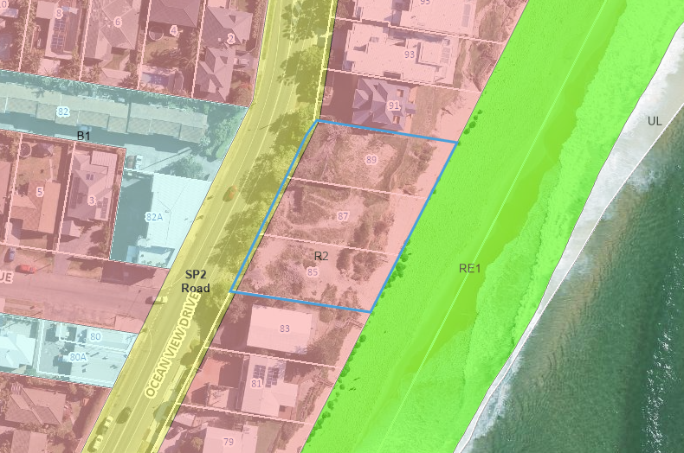
Figure 10 – Land Zoning Map Extract GLEP 2014

According to the definitions in Clause 1.4 (contained in the Dictionary), the proposal satisfies the definition of coastal protection works as defined in the Coastal Management Act 2016 as:

coastal protection works means—
(a) beach nourishment activities or works, and
(b) activities or works to reduce the impact of coastal hazards on land adjacent to tidal waters, including (but not limited to) seawalls, revetments and groynes.

Coastal protection works are not permitted in the R2 zone. The Resilience and Hazards SEPP prevails over the LEP pursuant to Section 2.5(1). In accordance with section 2.16 (1) of Resilience and Hazards SEPP, the proposed works are permissible with consent.

The zone objectives include the following (pursuant to the Land Use Table in Clause 2.3):

- To provide for the housing needs of the community within a low density residential environment.
- To enable other land uses that provide facilities or services to meet the day to day needs of residents.
- To ensure that development is compatible with the desired future character of the zone.
- To encourage best practice in the design of low-density residential development.
- To promote ecologically, socially and economically sustainable development and the need for, and value of, biodiversity in Gosford.
- To ensure that non-residential land uses do not adversely affect residential amenity or place demands on services beyond the level reasonably required for low-density housing.

The proposal is inconsistent with the objectives of the R2 Low Density Residential zone for the key issues in that the proposal does not:

- Maintain and enhance the residential amenity and character of the surrounding area.
  - The proposal is not consistent with the objectives for the character area Wamberal 1: Open Beachfront. The proposal is not compatible with the built form of multi-level beachfront dwellings and their ancillary structures approved in the locality, will have a detrimental impact on the highly sensitive existing landscape character and will have an adverse impact on the visual amenity and scenic qualities of the coast.
  - The proposal does not demonstrate compliance with the provisions of the Resilience and Hazards SEPP.
- The proposed seawall is a hard, regular, man-made and visually dominating concrete structure that is incompatible in character with the gentle sloping and irregular appearance of the beach and dune.
- The proposed seawall has a detrimental impact on the highly sensitive existing landscape character and will have an adverse impact on the visual amenity and scenic qualities of the coast.
- Promote ecologically, socially and economically sustainable development and the need for, and value of, biodiversity in Gosford.
  - Likely impacts of development - Insufficient information has been provided to grant consent as the proposed development within the coastal zone is likely to have potential end effects and increased risk of coastal hazards on that land or other land.

Reason for Refusal 4

General Controls and Development Standards (Part, 4, 5 and 7)

The LEP also contains controls relating to development standards, miscellaneous provisions and local provisions. The controls relevant to the proposal are considered in Table 4 below.

Table 4: Consideration of the LEP Controls
Control | Requirement | Proposal | Comply
Height of buildings  (Cl 4.3(2)) | 8.5m | Natural ground line at the beach interface of the seawall structure along the extent of the site frontage.  The height ranges from 4.8 to 5.8m.  The height of the seawall will fluctuate during weather events and coastal erosion processes. Beach amenity and scenic quality of the coastal line is addressed under SEPP Resilience and Hazards and Chapter 6.2 Coastal Frontage of GDCP 2013.  Note: in accordance with the EP&A Act definition of building includes ‘part of a building and any structure or part of a structure’ | Yes
Acid sulphate soils (ASS)  (Cl 7.1) | The land is listed as Class 5 ASS | The land is listed as Class 5 ASS and is located approximately 420 metres from adjacent Class 2  ASS (Terrigal Lagoon). Works are not likely to lower the water table below 1 metre in the adjacent Class 2 land; therefore, an ASS Management Plan is not required. | Yes
Development below mean high water mark  (Cl 5.7(2)) | Development consent is required to carry out development on any land below the mean high water mark of any body of water subject to tidal influence (including the bed of any such water). | Mean high water mark not indicated on plans | Yes
Flood planning (Cl 5.21) | The site is not subject to flood related development controls. | The site is not subject to flooding in the 1%AEP or Probable Maximum Floor (PMF) event. | N/A

The proposal is generally consistent with the GLEP 2014 Part 4, 5 and 7.

- Section 4.15 (1)(a)(ii) - Provisions of any Proposed Instruments

Central Coast Local Environmental Plan 2022

The Central Coast Local Environmental Plan 2022 (CCLEP 2022) was exhibited from 6 December 2018 to 28 February 2019 and adopted by Council on 14 December 2020. The CCLEP 2022 has been finalised, notified on 24 June 2022, and came into effect on 1 August 2022.

This application was lodged on 21 May 2021 and is subject to saving provisions under clause 1.8A of CCLEP 2022 and as such must be determined as if this plan had not commenced.

The assessment and determination of this application has been made under Gosford Local Environmental Plan 2014 (GLEP 2014).

Notwithstanding, the development standards and special provisions of CCLEP 2022 are discussed for the purpose of consistency.

- The subject site retains the R2 Low Density Residential zoning. The proposal is not permissible in the zone under the CCLEP 2022. The proposed development is permissible under the Resilience and Hazards SEPP.
  - The proposal is not considered to comply with the R2 Low Density zoning objectives for reasons outlined under comments provided to GLEP 2014 zoning provisions.
  - For the same reasons, the proposal does comply with the provisions of the R2 zone under the CCLEP 2022 as it does not maintain and enhance the residential amenity and character of the surrounding area.
  - The proposal does not demonstrate compliance with the provisions of the Resilience and Hazards SEPP. The consent authority cannot be satisfied that the proposed development within the coastal zone in relation to the potential end effects of the development and that the development is not likely to cause increased risk of coastal hazards on that land or other land.
- Clause 4.3(2) stipulates the maximum height for the land on the Height of Buildings Map which is 8.5m. The development proposes a height of 5m from natural ground line at the beach interface of the structure to the top of the pool.
- The Floor Space Ratio (FSR) for the land is not mapped on the Floor Space Ratio Map.
- Clause 5.21 & 5.22 - The site is not subject to flood related development controls.
- Clause 5.7 Development below mean high water mark - mean high water mark not indicated on plans.
- Clause 7.1 Acid Sulfate Soils - The land is listed as Class 5 ASS and is located approximately 420 metres from adjacent Class 2 ASS (Terrigal Lagoon). Works are not likely to lower the water table below 1 metre in the adjacent Class 2 land; therefore, an ASS Management Plan is not required.
- Clause 7.6 – Essential Services - the consent authority can be satisfied that the stated services that are essential for the development are available or that adequate arrangements have been made to make them available when required. The proposed coastal protection works and swimming pool have no measurable impact on the natural predevelopment water cycle. Should the application not be for refusal, conditions of consent would be applied for stormwater management (swimming pool overflow).
- Section 4.15(1)(a)(iii) - Provisions of any Development Control Plan

Gosford Development Control Plan 2013

The proposed development has been considered under the relevant provisions of Gosford Development Control Plan 2013 as follows:

Chapter 2.1 Character

The site is located within the character area: Wamberal 1: Open Beachfront of GDCP 2013 Chapter 2.1 Character.

The character statement provides for the desired character as follows:

These should remain low-density residential foreshores where future development does not dominate the informal scenic quality of prominent backdrops to Gosford City’s ocean beaches, and new dwellings are surrounded by leafy gardens that provide protection from storm surges and shoreline erosion.

Ensure that new structures do not disrupt development patterns that are evident upon surrounding properties. Avoid disturbing natural slopes plus any existing trees that are visually-prominent foreshore features, and ensure a leafy character for these prominent backdrops to ocean beaches. Plant gardens and street verges with low hedges and salt-tolerant trees that are predominantly indigenous, clustered to maintain existing panoramic views. Facing beachfronts in particular, avoid tall retaining walls or fences, extensive terraces or driveways that would visibly compromise the desired leafy character. Plant low-growing “hedges” of indigenous shrubs and ground covers along boundaries and to stabilise dunes. Also, maintain the informal character of any existing wide street verges that are dotted with shady street trees.

Avoid the appearance of a continuous wall of foreshore development by setting all building works back from exposed fore-dunes, and by surrounding buildings with leafy gardens. Incorporate waterfront and street setbacks that are similar to the surrounding properties, and provide at least one wide side setback or step the shape of front and rear facades.

Minimise the scale and bulk of new buildings or additions to existing dwellings. Use irregular floorplans to create well-articulated forms, such as linked pavilions that are separated by courtyards and capped by individual roofs. All roofs should be gently-pitched to minimise the height of ridges, flanked by wide eaves and verandahs to disguise the scale of exterior walls. Facing the beach, disguise the impact of upper storeys by a combination of extra setbacks from the ground floor plus shady balconies and verandahs.

Reflect elements of traditional coastal architecture and minimise the scale of prominent facades by using extensive windows and lightly-framed verandahs plus a variety of materials and finishes rather than expanses of plain masonry. All dwellings should display a “street address” with verandahs or decks, and living rooms or front doors that are visible from the roadway. Avoid wide garages that would visually-dominate any front façade or block views between the dwelling and the street. Locate and screen all balconies or decks to maintain existing levels of privacy and amenity that are enjoyed by neighbouring dwellings.

Comment:

Wamberal Beach is an important public space and characterised by the broad expanse of sand backed by the rising dune. The dune remains an extremely important element of local character and is highly sensitive to any changes.

Dune planting is an essential component of the landscape character of ocean beaches within the Central Coast, as well as contributing to the stabilisation of dunes and must be maintained.

The proposed seawall is a hard, regular, man-made and visually dominating concrete structure that is incompatible in character with the gentle sloping and irregular appearance of the beach and dune.

The Statement of Environmental Effects dated September 2021 states that the visual appearance of the sea wall will be softened by a series of landscaped terraces, as shown in the landscaping plans, thereby mitigating the bulk, scale and visual exposure of the proposed structure.

It is acknowledged that the Landscape Plan prepared by Terras, Rev B, dated 19 March 2021 provides suitable palette of trees, shrubs and ground covers that could survive in such a coastal exposed environment. Mulching and watering system was not mentioned in the Planting Plan, and therefore a condition of consent could be provided should the application be approved to address those features.

Notwithstanding, a landscape plan is provided, the proposed new structures are likely to cause increased coastal hazards to adjoining development, will disrupt development patterns that are evident upon surrounding properties. The pool proposes a 6m setback from the eastern boundary with the base of the pool at approx. RL 8.8m – 9.0m AHD.

In addition, the location of the proposed swimming pool is not in accordance with the desired character or scenic quality of the area wherein pools along the Wamberal Beachfront are integral of the dwelling design located centrally within the site and founded on deep piles. Locating the pool centrally on the site in this manner provides improved privacy and amenity for the subject site and neighbours.

The proposal is not compatible with the built form of multi-level beachfront dwellings and their ancillary structures approved in the locality, will have a detrimental impact on the highly sensitive existing landscape character and will have an adverse impact on the visual amenity and scenic qualities of the coast.

Chapter 2.2 Scenic Quality

The site is located within in the Forresters Beach - Wamberal Land Unit within the North Coastal Geographic Unit.

The principle aim of the Scenic Quality chapter is to provide guidelines for the interpretation and management of the scenic quality of the area in accordance with the development objectives of the landscape unit.

The landscape character is described as follows:
The Wamberal landscape Unit is more reflective of the area and consists of a diversity of characteristics. Urban development in Wamberal is not intrusive as it is contained within the forested ridge formed by COSS lands, Environmental/Conservation zoned areas and Wamberal Lagoon. The shopping centre does though detract from this character. Within the Wamberal urban areas the landform is generally open and limited large scale vegetation results in a moderate to high level of visual exposure. Rural-residential areas of Wamberal consist of a small, enclosed valley stretching between Matcham Road and Reads Road. The western portion of the valley is highly visible from The Entrance Road. This rural-residential area form a significant part of the rural buffer between Erina and Wamberal.

The above statement does not describe the relation to the contribution the Wamberal beachfront makes to the scenic landscape character of the unit, or management guidelines to ensure the protection of its landscape character.

The Wamberal Unit is of regional scenic value where opportunities for increases in densities and scale are available in areas not subject to visibility constraints or other physical constraints. Visually constrained areas include land along the beachfront.

The Statement of Environmental Effects dated September 2021 has not adequately provided justification to support the location of the pool as to why the pool cannot be located as far landward as possible to the existing dune and therefore closer to the proposed and approved dwellings or demonstrated compliance with development in the coastal zone and that satisfactory structural adequacy can be achieved.

The proposal is considered to be inconsistent with existing development along the Wamberal beachfront and will result in adverse visual impacts on the scenic quality of the area.

The proposal is not consistent with Chapter 2.1 Character and Chapter 2.2 Scenic Quality of GDCP 2013.

Reason for Refusal 5

Chapter 3.1 – Dwelling Houses, Secondary Dwelling and Ancillary Development

Chapter 3.1 provides development controls for swimming pools being ancillary development to a dwelling house in clause 3.1.7.4 Swimming Pools. DA/60465/2020 has been approved for a dwelling house on 85-87 Ocean View Drive.

The provisions of clause 3.1.7.4(i) states a swimming pool for private use should be located on a lot behind the setback area from a primary road or in the rear yard unless it can be justified that site constraints exist.

Where a property is located within the Coastal Hazard Area the provisions of clause 3.1.3.1b(iii) Rear Setback requires the rear setback of ancillary development to be considered under the provisions of Chapter 6.2 – Coastal Frontage.

The site constraints and amenity impact of locating the swimming pool on the beachfront behind the seawall is addressed elsewhere in this report.

Chapter 6.2 – Coastal Frontage

The site is subject to the provisions of Chapter 6.2 Coastal Frontage. In accordance with clause 6.2.7 Coastal Building Line - A coastal building line applies to coastal frontage areas in order to minimise coastal hazard impacts, including erosion, inundation and wave run­up, on property and development. All new development must be constructed landward of this coastal building line.

The proposal will be located seaward of the identified Coastal Building Line for Wamberal Beach. The Coastal Hazards Mapping is identified in Figure 11 below and indicates:

- Coastal Building Line (CBL) - red line.
- Coastal Hazard Area (where piling foundation is required) is hatched in pink.

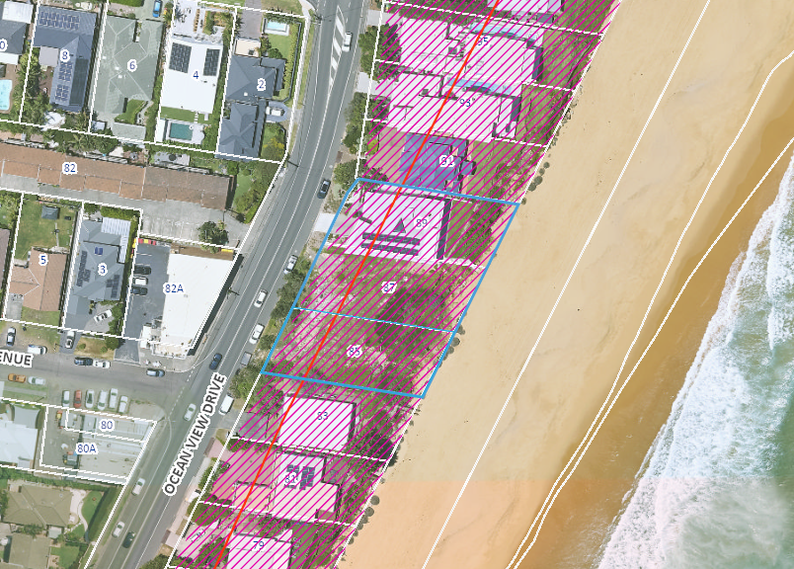
Figure 11 – Coastal Hazards Mapping Extract GDCP 2013

The application has been amended during the assessment of the proposal in relation to the swimming pools. The application initially proposed two swimming pools, one on 85-87 Ocean View Drive and one on 89 Ocean View Drive. Subsequently the pools were removed
from the proposal. The expert reports were amended to reflect the changes in the design of the proposal.

On 27 May 2023 applicant provided revised Architectural Plans Rev 3 dated 19 May 2023 reinstating the pool to 85-87 Ocean View Drive. Revised coastal and structural reports were not provided to address the amended design. On 20 March 2024 the applicant advised that further information will not be provided, and applicant requested Council determine the application on the information received.

DA/947/2024 for Coastal Protection Works along the entirely of Wamberal Beach was lodged with Council on 15 July 2024. This DA includes the subject site. This DA has not been determined. The revised architectural plans by Slater Architects, Rev 3 dated 19 May 2024 identifies the location of the proposed Coastal Protection Works under DA/947/2024, refer Figure 5 – Site Plan identified by the pink dashed line. Council requested the applicant demonstrate how the proposed works on the subject site integrated with DA/947/2024. No information was provided.

In accordance with Clause 6.2.10 the following documentation has been provided with the development application:

- Horton Coastal Engineering 2021a - dated 7 May 2021 - Coastal Engineering Report and Statement of Environmental Effects for Coastal Protection Works at 85-89 Ocean View Drive Wamberal (Council CM File No. D14628730).
- Horton Coastal Engineering 2021b - dated 31 August 2021 - Coastal Engineering Response to Council Request for Information on DA 60944/2021 for Coastal Protection Works at 85-89 Ocean View Drive Wamberal (Council CM File No. D14825957).
- Horton Coastal Engineering 2023 - dated 1 March 2023 - Coastal Engineering Response to Council Requests for Information on DA60944/2021 for Coastal Protection Works at 85-89 Ocean View Drive Wamberal, DA60465/2020 for Construction of a New Dwelling House and Swimming Pool at 85-87 Ocean View Drive Wamberal, and DA63277/2021 for a Swimming Pool and Associated Works at 89 Ocean View Drive Wamberal (Council CM File No. D15570914).
- Structural Engineering Plans, prepared by Northrop, Ref: NL201558, dated 22 January 2021 (Council CM File No. D14491366).
- Structural Engineering Advice, prepared by Northrop, Ref: NL201558, dated 25 February 2021 (Council CM File No. D14628724).
- Structural Engineering Advice and Plans, prepared by Northrop, Ref: NL201558, dated 31 August 2021 (Council CM File No. D14825960).
- Geotechnical Assessment, prepared by JK Geotechnics, Ref: 32215Rrpt, dated 22 January 2021 (Council CM File No. D14491354).

A peer review by an external coastal engineer, Royal HaskoningDHV June 2022, was undertaken which also encompassed separate applications on the site and the adjoining site, 89 Ocean View Drive.

The applicant provided a response from the Coastal Engineer, Horton Coastal Engineering 2023 to a request for information following findings in the Peer Review.

A further peer review from Royal HaskoningDHV was not sought by Council. Council’s internal Coastal Planning Officer provided final comment in relation to this application. A comprehensive assessment of the proposal is provided under Clause 2.12 of Chapter 2 Coastal Management of Resilience and Hazards SEPP.

The relevant development provisions are contained in clause 6.2.8.2b which states:

All structures constructed within a designated Coastal Hazard Area shall:

- be compatible with the coastal hazards identified;
- be founded landward of the coastal building line;
- not give rise to any increased coastal hazard
- be designed to not be damaged by the designated hazard;
- give consideration to the effects of larger events than the designated hazard;
- be constructed in a manner which overcomes any problem from the coastal hazards of runup and inundation; and
- be set back as far landward as practicable.

As identified in the assessment of the coastal hazard impact undertaken in accordance with the considerations of the Resilience and Hazards SEPP, insufficient information has been received to consider the potential end effects of the proposed seawall. Given that there is no additional geotechnical information and no further assessment demonstrating the end effects have been provided, the proposal is not supported. The proposal has not demonstrated compliance with clause 6.2.8.2b (iii) in that the proposal will not give rise to any increased coastal hazard.

The proposal has not suitably demonstrated the design is compatible with the objectives of clause 6.2.4. The development is not appropriate for the site having regard to the results of coastal, geotechnical, and structural investigations and does not ensure people and assets are safeguarded from risks associated with coastal hazards.

Reason for Refusal 6

Chapter 6.4 – Geotechnical Requirements for Development Applications

Chapter 6.4 provides a management strategy for development in areas identified as having landslip potential and guidelines on the content of geotechnical reports.

The Geotechnical Investigation prepared by JK Geotechnics dated 22 January 2021 provides recommendations for foundation designs to support Horton Coastal Engineers Advice and Northrop Structural Engineering Advice and Plans.

Assessment of the suitability of the geotechnical report has been considered by Royal HaskoningDHV 2022 as detailed under the Resilience and Hazards SEPP.

Chapter 7.2 – Waste Management

A revised Waste Management Plan prepared by Slater Architects dated 1 September 2021 has been submitted with the proposal.

Waste Management Plan provided however subject to comments from Council’s Environmental Health Office further assessment / Waste Management Strategy may be required. Waste from Asbestos Containing Material Contamination has been addressed under Chapter 4 Remediation of Land of Resilience and Hazards SEPP.

Appropriate conditions would be applied to the development consent should consent be issued.

Section 7.12 Local Infrastructure Contribution Plan 2024

The Central Coast Section 7.12 Local Infrastructure Contribution Plan 2024 applies to development pursuant to Section 7.18 of the EP&A Act and has been considered in the assessment of the proposal (notwithstanding Contributions plans are not DCPs they are required to be considered).

There are no transitional arrangements in place, therefore any subject contributions would be applied to an application based on the contributions plan in force at the date of application determination.

Development contributions are only levied where the proposal meets the cost of works thresholds and not subject to any exemption under this plan. The proposed development is exempt under clause 1.5 of the plan being for any development ordinarily incidental or ancillary to the use of the dwelling house which includes swimming pools and the coastal protection on the basis that such works world not otherwise be required if not for the dwelling house(s).

No development contributions levy is applicable in this instance.

- Section 4.15(1)(a)(iiia) – Planning agreements under Section 7.4 of the EP&A Act

There have been no planning agreements entered into and there are no draft planning agreements being proposed for the site.

- Section 4.15(1)(a)(iv) - Provisions of Regulations

The following relevant matters contained in the Environmental Planning and Assessment Regulation 2021 (EP&A Regulation 2021) must be taken into consideration by a consent authority in determining a development application:

- Matters contained in section 27 including:
  - In accordance with section 27 a development application for BASIX development must be accompanied by a relevant BASIX certificate issued no earlier than 3 months before the day on which the development application is submitted on the NSW planning portal.
  - A relevant BASIX certificate has not been provided.

These provisions of the EP&A Regulation 2021 have been considered and are addressed in the report.

  - Section 4.15(1)(b) - Likely Impacts of Development

The likely impacts of that development, including environmental impacts on both the natural and built environments, and social and economic impacts in the locality must be considered. In this regard, potential impacts related to the proposal have been considered in response to SEPPs, LEP and DCP controls outlined above.

The consideration of impacts on the natural and built environments includes the following:

- Context and setting
  - The proposal is not consistent with the context of the site and the adjacent Wamberal beach.
  - Insufficient information has been provided in relation to the potential end effects of the seawall in relation to the increased risk of coastal hazards on other land.
  - The proposal does not make satisfactory arrangements for the life of the works for their maintenance or for restoration of Wamberal Beach or land adjacent to it from increased erosion exacerbated by the proposed works.
  - The proposal will have an unacceptable adverse impact on the visual amenity and scenic qualities of the coast.
  - The proposal is not consistent with the character of surrounding development and retains large separation distance to adjoining rural residential allotments and therefore does not impact on the privacy and amenity of dwellings on adjoining properties.

- Public Domain, Natural Environment, Natural Hazards
  - The finds of Royal HaskoningDHV, coastal engineer engaged by Council to review the applicant’s engineering reports and plans has identified the proposal is likely to cause increased risk of coastal hazards on that land or other land. The applicant has not addressed to Council’s satisfaction the impact on coastal hazards and coastal process as discussed in the report to enable the consent authority to grant consent under Chapter 2 Coastal Management of the State Environmental Planning Policy (Resilience and Hazards) 2021.

- Water/air/soils impacts
  - The proposal has not adequately address erosion and sediment control requirements of the Bluebook (Landcom, 2004).

- Social and economic impact
  - While the proposed coastal protection works will provide for the protection of the landowner’s place of residence from loss due to coastal erosion and will be located within the private properties the social and economic benefits to the public and Council have not been adequately considered as to the effects on coastal processes and beach amenity. This is partly due to the lack of information and response of the applicant to address development controls within the coastal zone.

- Site design and internal design
  - The design solution comprising a series of reinforced concrete terraced planter beds extending upslope (landward) from the piled wall are supported by the piled wall returns, a series of footing beams and steel screw piles. One in-ground pool is proposed at the crest of, and suspended from, the coastal protection structure and additional screw piles. It is stated in the coastal engineering report that finite element numerical analysis will need to be completed in order to confirm the structural and coastal engineering design and the construction sequencing.
  - It is also noted that the adopted anchor design would be subject to the results of load testing during construction. While final structural design and certification of the installed anchors are matters for the geotechnical and structural engineer, it is suggested that Council monitor this situation for governance and to inform Council’s designs (or assessment of private designs) for coastal protection works at other select locations along the beach.
  - The proposed design of the coastal protection works have not been set out appropriately on the site to mitigate coastal impacts on adjoining development and the beach.
  - A Landscape Plan prepared by Terras, Rev B, dated 19 March 2021 is proposed to mitigate the bulk and scale of the seawall. The Plan provides suitable palette of trees, shrubs and ground covers that could survive in such a coastal exposed environment. Mulching and watering system was not mentioned in the Planting Plan, and therefore a condition of consent could be provided should the application be approved to address those features.
  - The location of the proposed swimming pool is not in accordance with the desired character or scenic quality of the area wherein pools along the Wamberal Beachfront are integral of the dwelling design located centrally within the site and founded on deep piles. Locating the pool in this manner provides improved privacy and amenity for the subject site and neighbours.
  - The design and location of the proposal is not compatible with the built form of multi-level beachfront dwellings and their ancillary structures approved in the locality, will have a detrimental impact on the highly sensitive existing landscape character and will have an adverse impact on the visual amenity and scenic qualities of the coast.

- Construction and Maintenance
  - Horton Coastal Engineering 2021b provided a response to Council’s request for a construction management plan and maintenance management plan to be provided prior to determination of the application.
  - This issue could be resolved through conditions of consent requiring Council approval prior to the issue of any construction certificate should the proposal not be recommended for refusal.

Accordingly, the proposal is not consistent with the relevant planning controls for development within the coastal zone under Chapter 2 Coastal Management of Resilience and Hazards SEPP due to the lack of information submitted during assessment. It is considered that the proposal will result in significant adverse impacts in the locality as outlined above and the application is recommended for refusal.

Reason for Refusal 7

  - Section 4.15(1)(c) - Suitability of the site

The site affected by coastal hazards and climate change. The impact of the development on coastal hazards has not been satisfactorily addressed in the application as discussed in the report. Insufficient information has been provided in relation to potential end effects which could increase the coastal hazard at the site and to neighbouring properties.

The proposed seawall is considered to have detrimental impact on the highly sensitive existing landscape character and will have an adverse impact on the visual amenity and scenic qualities of the coast.

The proposed development has not addressed the site constraints required for development within a sensitive coastal location and the application is recommended for refusal.

Reason for Refusal 8

  - Section 4.15(1)(d) - Public Submissions

These submissions are considered in Section 5 of this report.

  - Section 4.15(1)(e) - Public interest

Approval of the proposed development is not in the public interest for the following reasons:

- The potential impacts identified in the report for development in the coastal zone have not been satisfactorily addressed to enable Council’s coastal experts to consider the impacts and risks from coastal hazards on other land being private properties and public beach.
- The proposal is inconsistent with the planning controls for development within the coastal zone under Chapter 2 Coastal Management of Resilience and Hazards SEPP due to the lack of information submitted during assessment.
- While the proposed coastal protection works will provide for the protection of the landowner’s place of residence from loss due to coastal erosion and will be located within the private properties the social and economic benefits to the public and Council have not been adequately considered as to the effects on coastal processes and beach amenity. This is partly due to the lack of information and response of the applicant to address development controls within the coastal zone.
- The proposal is not considered consistent with ecologically sustainable development principles through the lack of information addressing the environmental issues to consider the proposal will not decrease environmental quality of the beach for future generations.
- The potential impacts of climate change on the development have been considered in the design life of the proposal by Horton Coastal Engineering. However, further information was required by Council’s external coastal engineer in relation to the height of the seawall and potential wave overtopping. Council’s Coastal Planning Officer reviewed the response however cannot support the proposal for reasons outlined in this report.

On balance, for the reasons stated above including not being compatible with the constraints of the site it is considered that the proposed development is not in the public interest and the application is recommended for refusal.

Reason for Refusal 9

- REFERRALS AND SUBMISSIONS

  - Agency Referrals and Concurrence

The development application was not referred to any agencies for comment/concurrence/referral.

  - Council Officer Referrals

The development application has been referred to various Council officers for technical review as outlined Table 5.

Table 5: Consideration of Council Referrals
Officer | Comments | Resolved
Coastal Planning Officer | Recommended that an independent consultant be engaged to provide assessment on the coastal aspects of the proposal and to provide review of the submitted coastal engineering report.  Response from applicant to the review of the independent consultant Review, including amended plans and supporting. | Y  Proposal reviewed by independent consultant.  N
Coastal  Engineering | Proposal reviewed by independent consultant | N
Trees | Landscape Plan provided. The Planting Plan by Terras 19/3/21 provides a very suitable palette of trees, shrubs and ground covers that could survive in such a coastal exposed environment. Mulching and watering system was not mentioned in the Planting Plan, therefore a condition is provided to address those features. | Y
Health | The Sediment & Erosion & Waste Management Plan has been reviewed and does not meet the minimum requirements of Gosford DCP Chapter 6.3 (repealed), and the Bluebook (Landcom, 2004). A proposed sand bund seaward of the works is proposed outside the property boundary on crown land (the beach). Further, a LEC decision for similar works at 29 Pacific St, Wamberal did not allow sediment and erosion control works outside the property boundary on the beach (see DA52565/2017). Standard construction drawings, staging of works and location of sediment control measures and erosion control measures during elevated wave and water levels has not been provided.  Insufficient information has been provided to address the above. | N
Waste | Waste Management Plan provided however subject to comments from Health further assessment / Waste Management Strategy may be required. | Y

The outstanding issues raised by Council officers are considered in the Key Issues section of this report.

  - Community Consultation

The proposal was notified in accordance with Chapter 7.3 of the GDCP 2013 from 21 May 2021 to 11 June 2021 on Council’s website. A total of 5 submissions were received by way of objection.

The revised proposal (removal of swimming pools) was notified 5 October 2021 to 26 October 2021 on Council’s webstie. A total of 46 submissions were received by way of objection and 2 submissions in support stating the proposal is an excellent initiative to protect property.

The second notification period occurred during the exhibition of the Wamberal Beach Terminal Protection & Sand Nourishment Project.

The issues raised in these submissions are considered in Table 6.

Table 6: Community Submissions
Issue | Council Comments
Detrimental impact on the coastal foreshore and adjacent properties. | Insufficient information has been provided in relation to the potential end effects of the seawall in relation to the increased risk of coastal hazards on other land.  Outcome: The application has not demonstrated the proposal will not cause increased risk of coastal hazards on other land. The proposal is recommended for refusal.
Maintenance –  No commitment to ongoing sand nourishment by the proponents. Financial burden on private property owners.  Burden on community to maintain and repair / higher costs to rate payers. | Insufficient information has been provided with the application. The proposal does not make satisfactory arrangements for the life of the works for their maintenance or for restoration of Wamberal Beach or land adjacent to it from increased erosion exacerbated by the proposed works.  Outcome: The proposal is recommended for refusal.
Other measures to save Wamberal Beach -  Council is encouraged to also look at measures to manage adjacent sections of the beach through a targeted planned retreat strategy to stabilise the wider beach dune system so as to ensure the maintenance of public amenity and to enhance the tourism potential of the popular beach. | The proposed seawall is considered to have detrimental impact on the highly sensitive existing landscape character and will have an adverse impact on the visual amenity and scenic qualities of the coast.  Outcome: The proposal is recommended for refusal.  The Open Coast Coastal Management Program is currently on exhibition. Central Coast Council is developing five Coastal Management Programs (CMPs) to guide the long-term, sustainable management of our coastal environments. The community is encouraged to have a say.
Works would create an unwanted precedent for seawalls along the beaches. The southern end of Terrigal Beach is an example of public beach no longer usable. | Sea Wall - Coastal Protection Works has been approved by the Land and Environment Court in 2018 for properties at 23A, 23B, 25C, 29, 31 and 33 Pacific Street under DA/52565/2017. In addition, DA/947/2024 for Coastal Protection Works is currently under assessment for the whole of Wamberal Beach.  Notwithstanding this, applications of this nature are considered on merit. In this instance, the application has not demonstrated the proposal will not cause increased risk of coastal hazards on other land.  Outcome: The proposal is recommended for refusal.
Contamination -  The area of land that the proposed works are to be carried out on has been subject to erosion that has exposed old land fill. Central Coast Council is aware of this situation along Wamberal beach and has posted signage to alert the Public that Asbestos has been discovered in similar areas along Wamberal Beach. The risk of further exposure of Asbestos due to earthworks should be carefully considered and if deemed a risk suitable measure would need to be adopted to minimise risk to the public | Anecdotal evidence suggests that historically waste material, including asbestos, has been imported as fill material for houses along Wamberal Beach. Council continues to collect asbestos fragments and other wastes from the beach following storm events. Waste classification conditions will be applied for any fill material removed from the site. Additional conditions would be applied to should consent be granted to ensure that waste material present on the land (concrete/rubble/bricks) and any buried waste is not used as fill material.

- KEY ISSUES

The following key issues are relevant to the assessment of this application having considered the relevant planning controls and the proposal in detail:

  - Inconsistent with R2 Low Density zone objectives

The proposal is inconsistent with the objectives of the R2 Low Density Residential zone for the key issues in that the proposal does not:

- Maintain and enhance the residential amenity and character of the surrounding area.
- Promote ecologically, socially and economically sustainable development and the need for, and value of, biodiversity in Gosford.

The proposed coastal protection works are permissible under section 2.16 of the Resilience and Hazards SEPP. As discussed in the report under the Resilience and Hazards SEPP insufficient information has been provided to enable the consent authority to grant consent under section 2.12. The consent authority cannot be satisfied that the proposed development within the coastal zone in relation to the potential end effects of the development will not cause increased risk of coastal hazards on that land or other land.

In this regard, the applicant has not addressed this issue satisfactorily with amended plans or reports and accordingly, this issue remains outstanding.

Resolution: The issue has not been resolved and accordingly, warrants refusal of the application.

  - Coastal Protection Works

Insufficient information has been provided in relation to the key issues identified in the Briefing Report. These key issues are discussed in detail in the report under Chapter 2 Coastal Management of the Resilience and Hazards SEPP and Chapter 6.2 Coastal Frontage of Gosford Development Control Plan 2013.

The applicant has not addressed this issue satisfactorily with amended plans or reports and accordingly, this issue remains outstanding.

Resolution: The issue has not been resolved and accordingly, warrants refusal of the application.

  - Sediment and Erosion Control

- The Sediment & Erosion & Waste Management Plan (Drawing No. S05.01, Rev.3) does not meet the minimum requirements of Gosford DCP Chapter 6.3 and the Bluebook (Landcom, 2004).
- The proposed sand bund seaward of the works is proposed outside the property boundary, all sediment and erosion control measures are to be placed within the property boundary. Further, a LEC decision for similar works at 29 Pacific St, Wamberal did not allow sediment and erosion control works outside the property boundary (i.e. on the beach (see DA52565/2017)).
- The following further information is requested:
  - Remove sand bund on public land from the Plan.
  - Provide diversion of clean/dirty water landward of disturbed areas.
  - Provide location on the plan of all control measures such as stockpiles.
  - Provide detailed information for stabilisation of work area during elevated wave and water levels during construction stage, including plan to monitor conditions (swell conditions, tides) and carry out stabilisation of construction area during specific conditions.
  - Provide standard construction drawings in accordance with the BlueBook for all control.

A revised Sediment & Erosion Control Plan has not been provided.

Resolution: This issue could be resolved through conditions of consent requiring Council approval prior to the issue of any construction certificate should the proposal not be recommended for refusal.

5.4 Maintenance Management

- A construction management plan is required and should include machinery and equipment plan during construction phase.

- A maintenance management plan is required for the life of the proposed structure.

Horton Coastal Engineering 2021b provided a response to Council’s request for a construction management plan and maintenance management plan to be provided prior to determination of the application.

Resolution: This issue could be resolved through conditions of consent requiring Council approval prior to the issue of any construction certificate should the proposal not be recommended for refusal.

- CONCLUSION

This development application has been considered in accordance with the requirements of the EP&A Act and the Regulations as outlined in this report. Following a thorough assessment of the relevant planning controls, issues raised in submissions and the key issues identified in this report, it is considered that the application cannot be supported.

The likely impacts of the development outlined in Key Issues Section 5.1 and 5.2 have not been resolved satisfactorily through amendments to the proposal.

- RECOMMENDATION

That the Development Application DA/60944/2021 for Coastal Protection Works & Swimming Pool at Lot 3 DP 12022, Lot 2 DP 12022, Lot 1 DP 12022, 85, 87, 89 Ocean View Drive Wamberal be REFUSED pursuant to Section 4.16(1)(b) of the Environmental Planning and Assessment Act 1979 subject to the reasons for refusal attached to this report at Attachment A.

The following attachments are provided:

- Attachment A: Reasons for refusal

